Cover Sheet

Section 1

About Me
My Name Is Andrea DeLaCruz
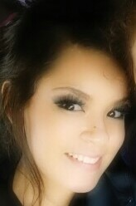
I am a blessed mother of two beautiful girls, Alyssa seven -years old, and Kayleeh three years-old. I also have handsome baby boy he is currently ten months.
I am a substitute teacher for Midland Independent School District and I am working on becoming and ESL teacher.

Family * LOVE * EDUCATION * SUCCESS * 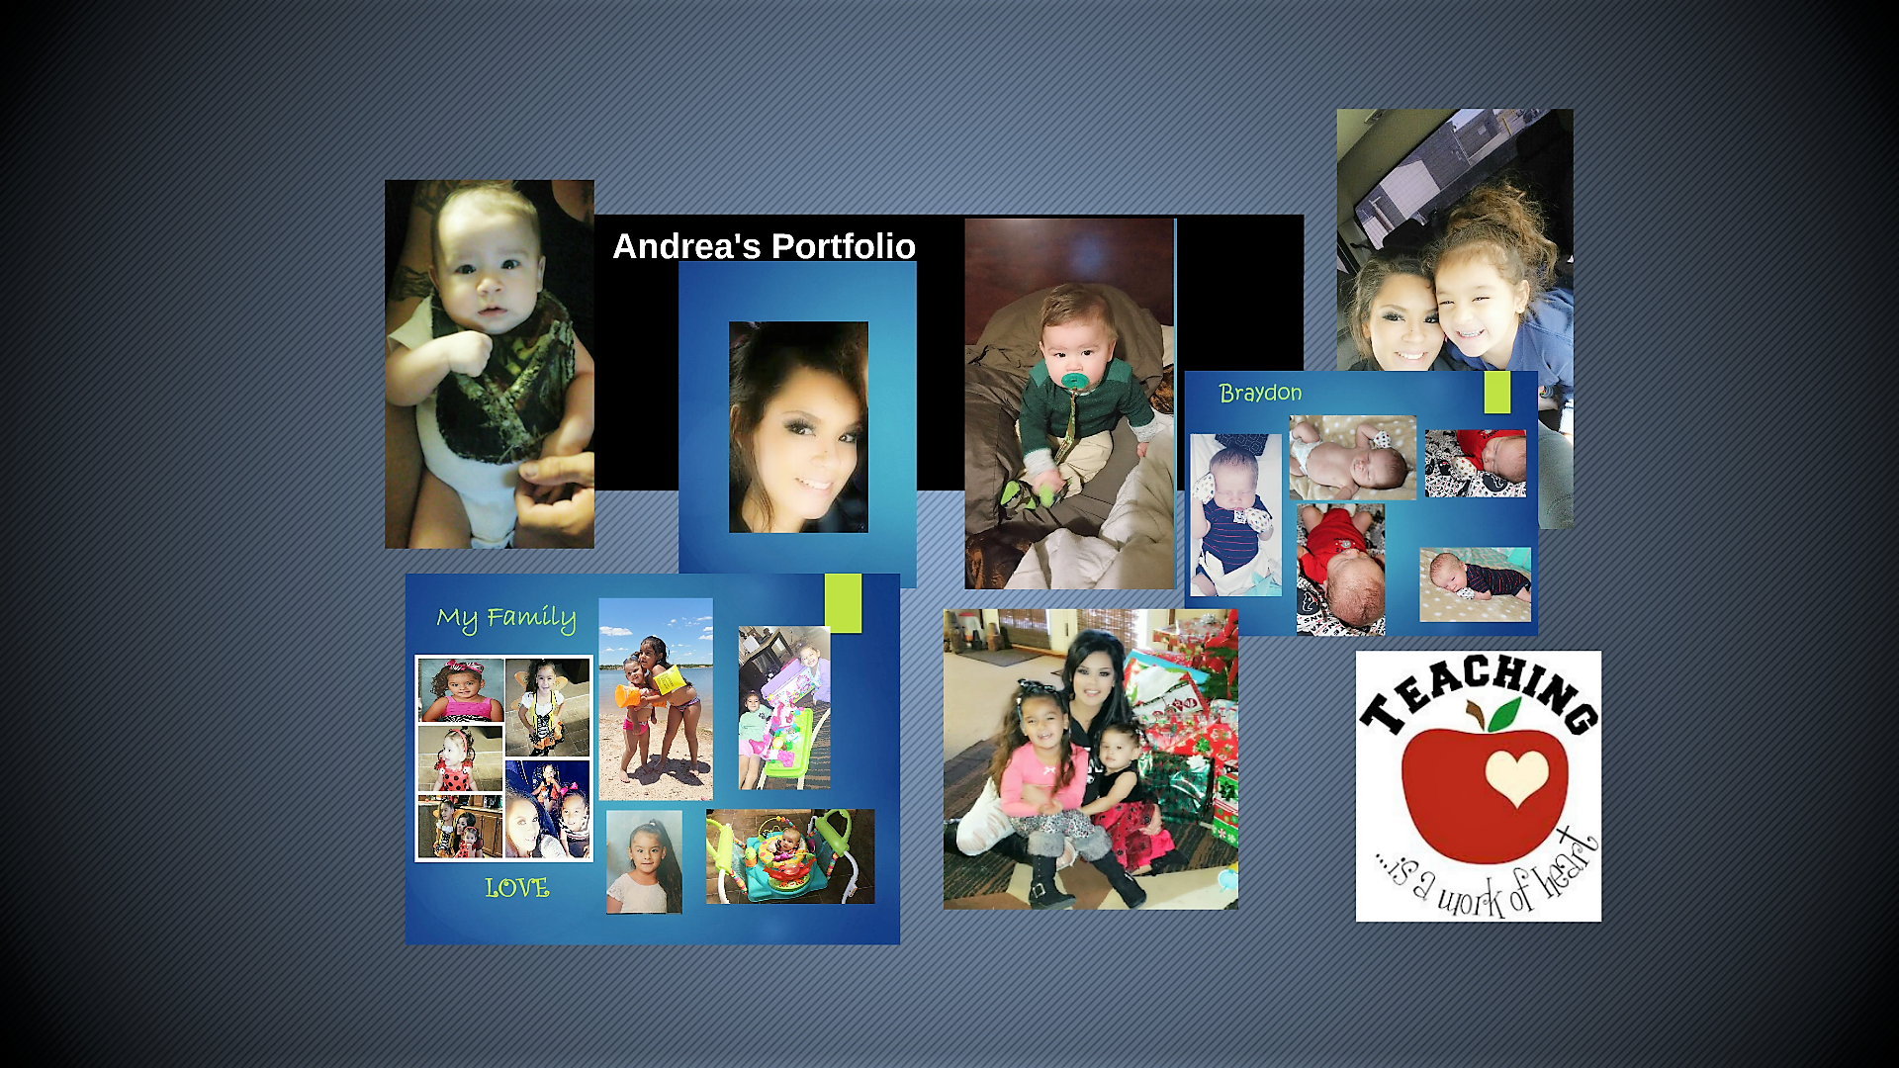IMPROVISE * MEANINGFUL

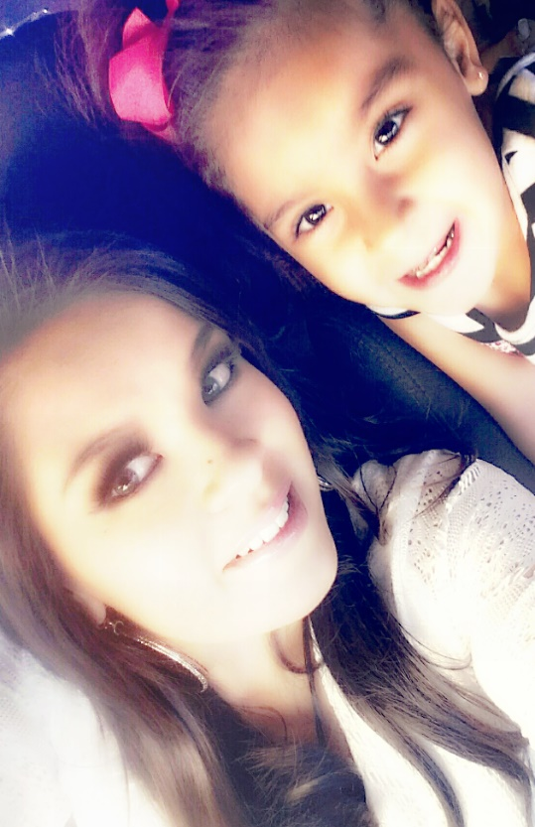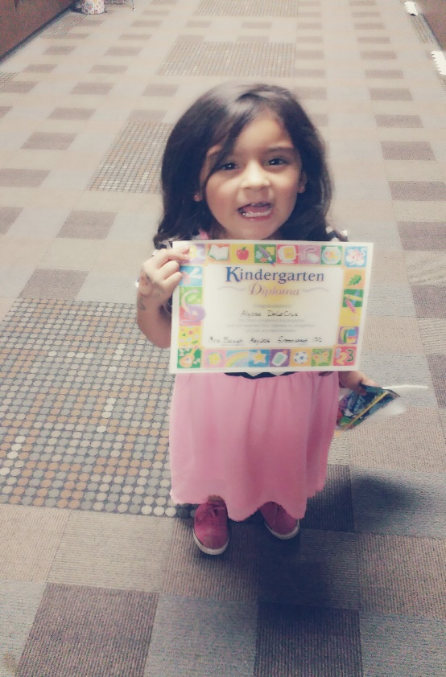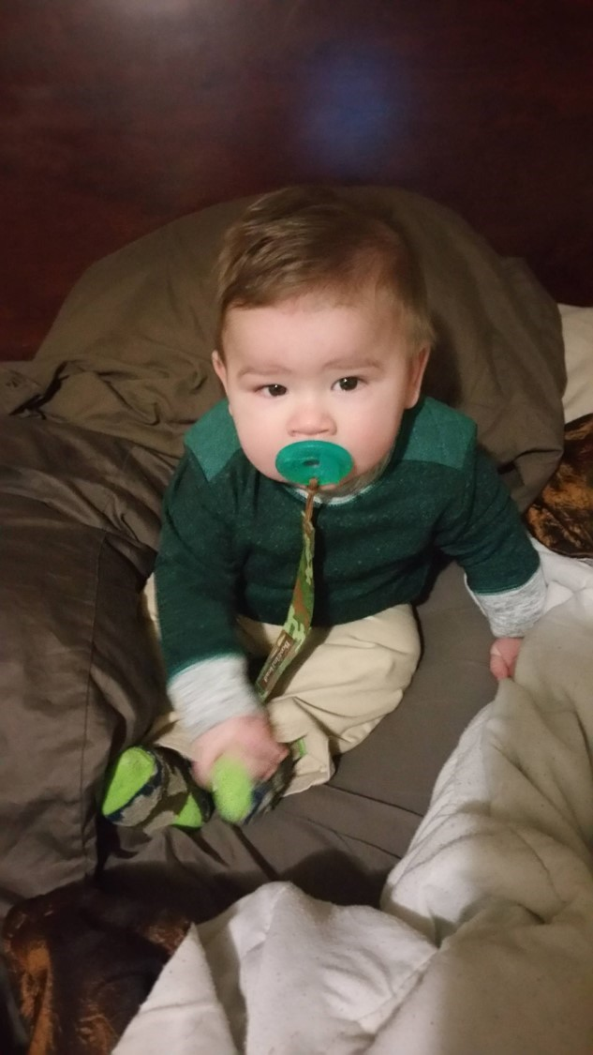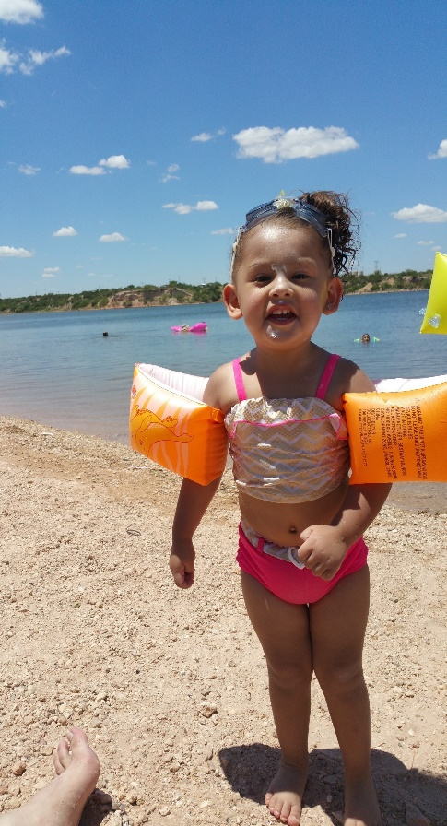
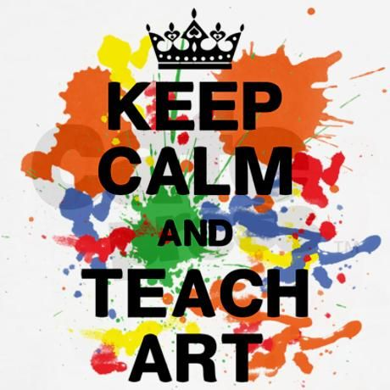
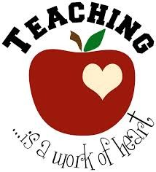


Definition of Arts Integration

Definition
When teachers integrate art it helps students develop and grow the skills of communication and problem solving across disciplines.
Integration= Combining (one thing) with another so that they become a whole.
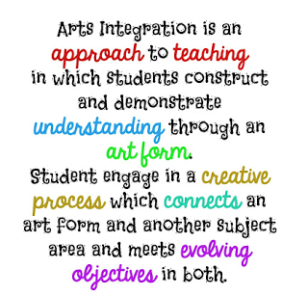

https://ww2.kqed.org/mindshift/2015/01/13/how-integrating-arts-into-other-subjects-makes-learning-come-alive/

What does integration really mean? Please click on link to view.
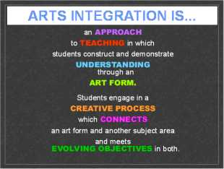

Definition- Integration is derived from the Latin word integrare, which means "to make whole" (Grumet, 2004). Throughout its history, the concept of integration has operated under many labels, such as interdisciplinary instruction, unit teaching, the protect approach, inquiry method and whole language. By any name, it is combining diverse elements into harmonious whole which a synergistic result. Art integration is the meaningful use of arts processes and content to introduce, develop, or bring closure to lessons in any academic area.
Developmentally, the arts provide a means for children as they learn to represent images and ideas. Representation is a major focus of early learning. Dramatic play sets the stage for creative language and symbolic development, especially in an environment that includes a variety of materials. For example, while helping my six- year old daughter with her spelling words we like to get creative, sometimes I’ll ask her to show me how to spell it with her whole body, kind of like the YMCA song where we use our body to spell out YMCA. She enjoys that, she also likes to rhyme her spelling words and we make a little poem based off a recent song we listened to earlier that day. This engages her, rather than the typical writing them five times each. She finds that boring and I can tell because her hand writing gets sloppy toward the end, and sometimes doesn’t spell it out correctly. I have found incorporating the arts’ techniques has been successful with her learning style, and I can assume it may work for all learning styles.
Describe 2 ways "playing with words"/poetry can be introduced to children in creative ways? One way playing with words can be introduced is a picture, showing the students a picture can open a mind if imagination, they can come up with whatever story they’d like. Another way is music and dancing, to tell their story. My two-year old daughter loves both. My six-year old daughter has learned a great deal of material by simply incorporating little things such as music, drama, and arts. The learners will love to learn if they are enjoying it. I have seen results with my six-year old daughter.
How do the authors feel picto-spelling learning engages students? Students engage in creative thinking while learning specific spelling and vocabulary. Picto-spelling provides a concrete indication of their understanding of specific words.

STEAM
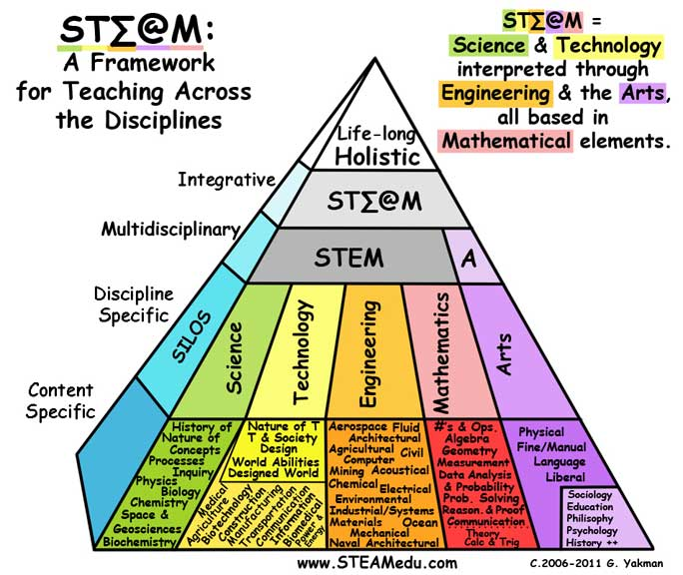
STEAM = Science & Technology interpreted through Engineering & the Arts, all based in Mathematical elements.
STEAM is a way to teach how all things relate to each other, in school and in life. It’s more fun than traditional learning styles and makes more sense to all types of learners because it is based on the natural ways that people learn and are interested in things.

Please visit https://steamedu.com/about-us/

TEKS - Texas Essential Knowledge PK- 6th
http://tea.texas.gov/index2.aspx?id=6148

Texas Essential Knowledge and Skills by Grade Level (Elementary)


Kindergarten
1st Grade
2nd Grade
3rd Grade
4th Grade
5th Grade
6th Grade
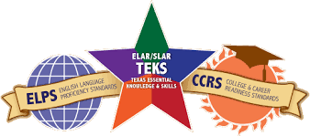

National Arts Standards
The National Core Arts Standards are designed to serve an eminently practical purpose—to improve the teaching and learning of the arts in America’s schools, thereby improving the education of more than 50 million students annually. To accomplish this goal, the standards have been written mindful of the realities faced by our nation’s metropolitan, rural, suburban and independent school districts in the 21st century. Key among those realities is increased attention to accountability for instruction and achievement. The new arts standards will help address this priority.
https://www.slideshare.net/nwalkup/art-teks-for-quilting-wichita-falls-together

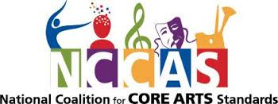
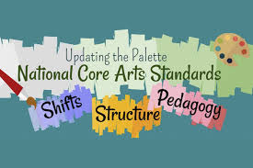

Teaching Philosophy
Andrea DeLaCruz’s Philosophy of Education

My educational philosophy is composed of many ideas and skills. Integrating the Arts is very important as I have learned throughout my educational courses. All learners are different and will all learn differently I believe all people are unique in their own way, and learn differently. Hence, it is vital communication is clear and precise. For the learner to reach the maximum level of learning, all levels of Maslow's stages must be achieved. It is critical for me as a future teacher to know my students and figure out what method best works for them. Meaningful Arts Integration motivates problem-solving skills, creative capacities, plus broader multicultural understanding. All learning styles, cognitive styles, and styles based on culture and unique learning needs along with individual learning needs must be evaluated carefully. As a future teacher, I believe it is extremely important for the teacher to be passionate in teaching and understand our diverse students. Being a mother of three gorgeous children I understand it is extremely important for them to have a successful education and continue their education. Personally, the purpose of schooling is for students to grow and expand their way of thinking and become successful. Although, it is important to teach students the core subjects I strongly believe the most important thing is providing them meaningful arts integration and believing in them. In addition, students need positive feedback and simply showing them you care about them. In my opinion teachers should instruct students with differentiated instruction, universal design for learning and incorporate meaningful arts integration with dedication and passion. Our kids are our future and have enormous potential to grow and expand their knowledge to great capacities.
Throughout my education courses and observation hours I have completed I have come across a variety of types of students in which are unique in their own ways including At- Risk students; students who are likely to struggle or fail in school due to social circumstances, GT students; a child or youth who performs at or shows the potential for performing at a remarkably high level of accomplishment when compared to others of the same age, ELL; English language learners; refers to students whose first language is not English but who are learning English, and students with disabilities, there is a wide range of disabilities including autism, chronic illness, hearing loss and deafness, intellectual disability learning disability and the list goes on. I believe the purpose of teaching is for children to have a successful education.Without an education a student will never be the best he or she could ever be. Students need schooling to have a healthy and wealthy life. Research states students without an education fail to thrive in life, and end up somewhere they do not. Thus, it is the teacher’s position to understand that all students vary.
As a future teacher, I think it is important for a teacher to incorporate AI to activate creative problem solving that triggers higher level thinking, critical thinking and cooperation. Studies propose arts integration greatly impacts deep learning, increases academic achievement, and levels the playing field for minority groups and students with learning differences. The Kennedy Center defines arts integration as "An approach to teaching in which students construct and demonstrate understanding through an art form. Students engage in a creative process which connects an art form and another subject area and meets evolving objectives in both." AI flawlessly merges arts standards with core curricula to build connections and provide engaging context. It is suitable for every diverse learner. For example, spatial learner will thrive in visual arts integration. Kinesthetic learner will thrive in music or drama integration. Aural learner will thrive in music integration and the verbal learner will thrive in which ever arts integration of their choice, because arts integration is suitable for everyone. The teacher must be dedicated and motivated to teach the students what he or she is specialized in teaching, and most important teaching a student that he or she can achieve and be successful. Encouraging and inspiring my future students and being the ultimate role model will result in academic success.
Teachers should understand and know that he or she will not be able to instruct successfully if the students’ needs are not met. The teacher must be dedicated and have much respect for what he or she teaches with grand passion. Instructing with universal design for learning, differentiating instruction and art integration will result in a successful and effective classroom for all my students as well as At-risk, ELL, GT and disabled students. Each and every student is unique in their own special way, and by compassionately teaching as a professional teacher, I know I will succeed to my potential at being the best teacher.
To view my full philosophy please click here

Language Arts - Elementary

Quick examples of Arts Integration
Visual: Create a visual to illustrate the main idea, problem or theme of a story. Examples: Post Cards illustrated with letter from character, Poster for book or book made into movie poster. Theater: Create a board game of your favorite book. Create Masks of Character in story and perform as a readers theater or write a sequel to story and perform. Music
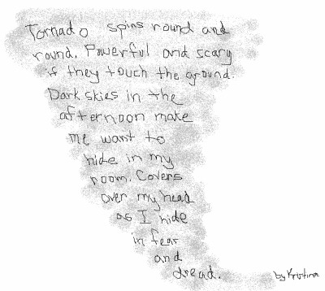
Drawing a tornado while creating a poem
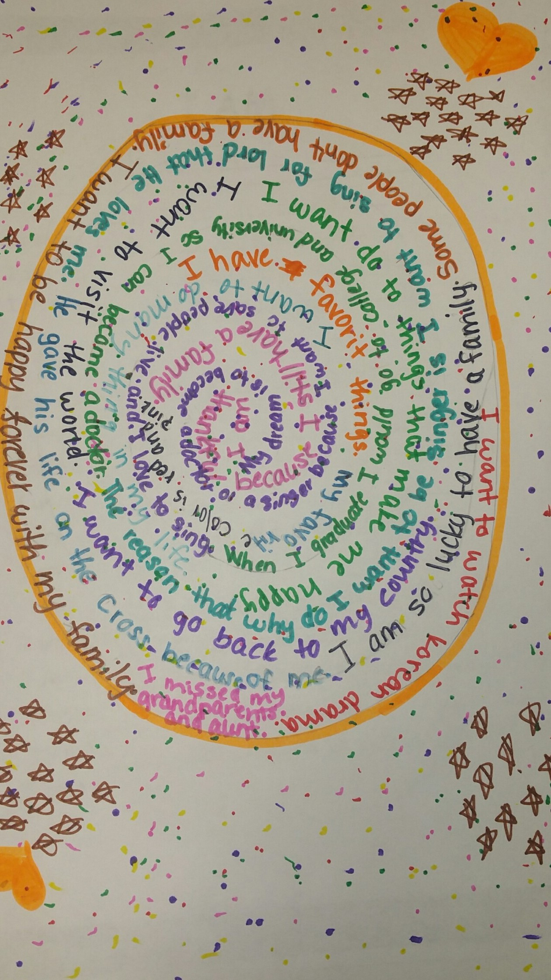

Visual Arts
Puppetry while reading
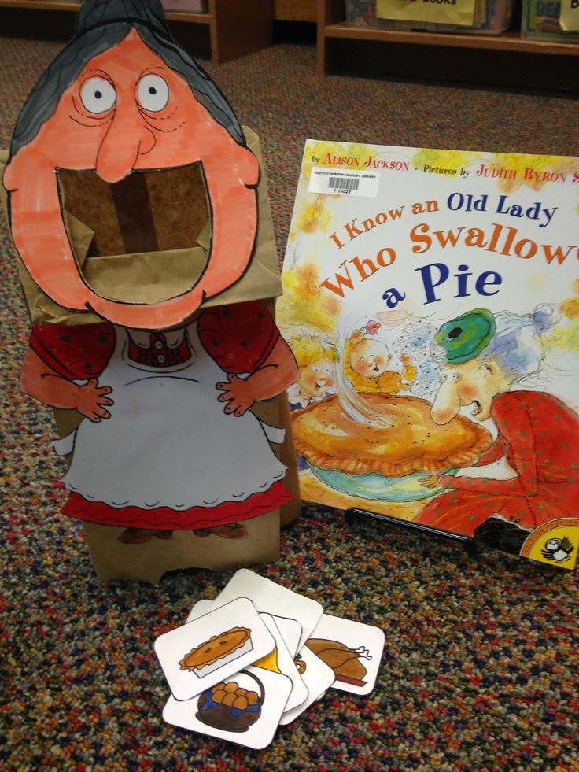
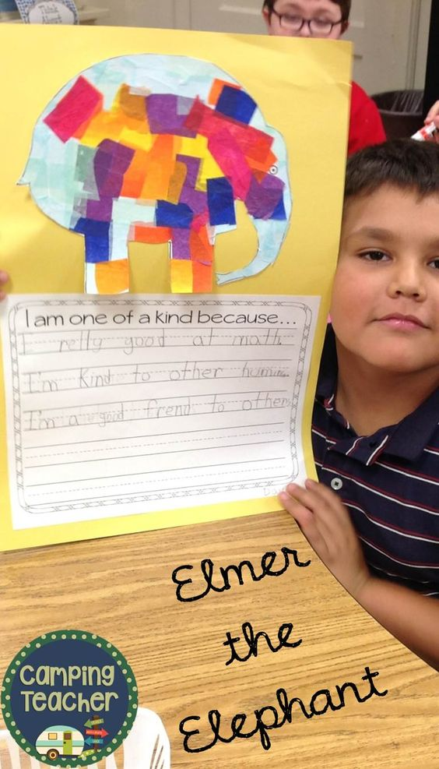

Have students make their own diary and write in it every day.
Theater
- Create a board game of your favorite book.
- Pretend and Write. Dear Abby, Journals, Letters.
- Point of View Roles
- Theme Tableau
- Readers Theatre or Radio Plays
- Create Masks of Character in story and perform as a readers theater or write a sequel to story and perform
Documentation of an artist-in-residence program with theater artist Steve Busa and teacher Mia Robinson at Kewaydin Elementary School in Minneapolis.
Tableau is a project of Arts for Academic Achievement funded by the Ford Foundation.
Arts integration in the classroom is a successful strategy to increase reading comprehension, capacity for learning and decrease the achievement gap.
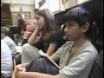Watch Video
Tableau: Theater and Language Arts
User: n/a - Added: 1/4/10

TheatreWorks, the nationally acclaimed theatre of Silicon Valley, creates the TELL Project, Theatre for English Language Learners, placing TheatreWorks teaching artists in short residencies with ESL classroom teachers to promote English language acquisition through theatre arts.
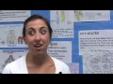Watch Video
TheatreWorks presents " Theatre for English Language Learners: the TELL Project"
User: n/a - Added: 6/9/10

Poetry isn’t always easy for students. But with hands-on engagement, they gain new understanding. Take Robert Frost’s “Pasture.” Instead of just reading and discussing the work in a typical classroom setting, students made 21st-century dioramas with robotic tool kits containing sensors, motors, LEDs, and a controller. One student made a blue plastic wrap lake in an old cardboard photocopy-paper box that vibrated, thanks to the motor, and, lit up, thanks to the LED. When the student said the word “water”—students record themselves reading the poems aloud in the audio-editing program Audacity—the LED turned the plastic wrap a deeper shade of blue. When he got to the bit about the “tottering” calf, the motor made the toy calf vibrate.
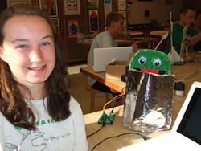
Combining Robotics With Poetry? Art and Engineering Can Co-Exist
Click here to view link.

The Chinese Lion Dance Does the Chinese Lion Dance really bring good luck? Join in the happy Chinese Lion Dance!
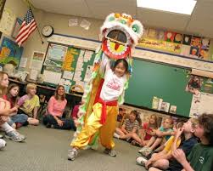
Click here to view
Summary
The Chinese Lion Dance is an important part of the celebration of the Chinese New Year, and it is believed to bring good luck and happiness. In this lesson, students will learn about the history of this dance, the costumes that are worn, and the music that accompanies the dance performance. They will create lion head puppets and will dance in a parade carrying their Chinese Lion Dance puppets.
Learning Objectives Students will:
- Locate China on a world map
- Listen to a story of the Chinese Lion Dance
- Explore information on a website featuring the Chinese Lion Dance
- Answer questions concerning the history and culture of the dance
- View a video featuring the Chinese Lion Dance
- Create puppets based on the Chinese Lion Dance
- Dance in a Chinese Lion Dance parade
Teaching Approach
- Comprehensive Arts Education
- Arts Integration
Teaching Methods
- Brainstorming
- Guided Listening
- Discussion
- Visual Instruction
Assessment Type
- Informal Assessment

Music
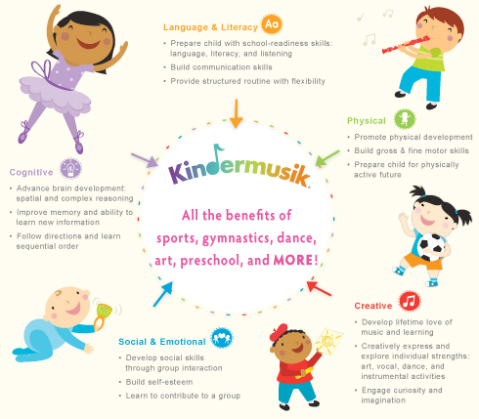
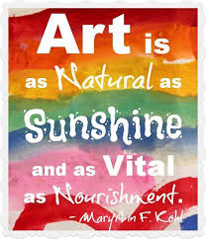

#1 Songs to Teach Academic Vocabulary Using music as an aid in memorization is just plain smart. Add in songs that are focused in your content area, and they're gold. That's why history teachers still use "Elbow Room" from Schoolhouse Rock fame to introduce the concept of exploration.
#2 Lyrics as Poetry
#3 Songs as Writing Prompts Picture this. The students enter the classroom. John Williams is playing on the speakers. Maybe it's the ominous opening from the film Jaws or the flying sequence from Hook. Now write.
#4 Music to Aid in Role-Playing
#5 Developing Playlists to Teach Narrative there would be something interesting to have the students develop a mythical playlist, a mix-tape of sorts, that tells a story through its song titles.
#6 Jingles to Teach Persuasive Commercials jingles are a great way to show that people are writing persuasively in many genres and in many modalities. Have students analyze a jingle as you might analyze an article or review. Better yet, have them write one.
#7 Reviews as Literary Analysis Music reviews are persuasive, sure, but they are also a form of literary analysis. Look at Amazon reviews or Rolling Stone reviews for elements of analysis. Have students listen to the music they are referring to. Did the reviewer miss the boat? Do they agree with the review and what evidence can they bring to the table to prove their analyses?
#8 Music to take "Syn-naps" Last, simply turn on a good tune every now and then. This is when you wake up the brain by jolting it a bit. Sometimes you can use an image stuck in the middle of a Powerpoint slide, but music works beautifully as well. It doesn't have the last long, merely a stanza or two, but enough to get the oxygen back to their noggin' and the alertness back in their eyes.
Retrieved from
https://www.edutopia.org/blog/using-music-strategies-language-arts-classroom-heather-wolpert-gawron click to view more

Lesson Plan We Created for this Class
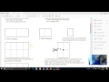Watch Video
Lesson Plan Dr. Gluck
User: n/a - Added: 4/8/17

For the full lesson plan please click here

Websites / Documents
All websites posted above

Language Arts Professional Organizations
Professional Organizations for English Teachers

Language Arts Periodicals
Language Arts Periodicals
Please click here for periodicals

Language Arts Books
Punctuation Takes a Vacation
By Robin Pulver Illustrated by Lynn Rowe Reed
When the punctuation marks in Mr. Wright's classroom go on a vacation, the class immediately misses them, as nothing makes sense.The punctuation marks then send back postcards, full of clever wordplay that require sleuthing to figure out which marks sent which cards.
Great for teaching punctuation!
Reading Level
Interest Level: Gr. 1-3
DRA Level: 28
Lexile Measure: 370L
Grade Equivalent: 2.9
Guided Reading: M
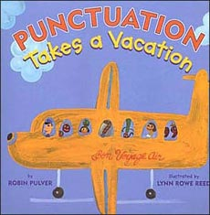
Click here for more

Simile
Books with Smilies
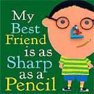click here for more
Owl Moon
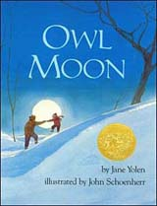
Owl Moon by Jane Yolen;
illustrated by John Schoenherr
A visitor to this website wrote in to say Owl Moon is a great book to use when teaching similes,
plus here is a lesson plan on line using this title to teach similes and metaphors here.

Alfie the Apostrophe
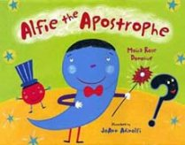
Alfie the Apostrophe (punctuation marks hold a talent show and each mark plays its role)
by Moira Donohue 1st grade - 4th grade

If you Were a Contraction
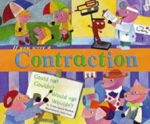
written by Trisha Shasken illustrated by Sara Gray
As teachers, we can attest that teaching contractions can be very challenging ...
but If You Were a Contraction can help.
With the same funky illustrations as the other books in the series and lots of examples,
this is a solid basic introduction.

Mathematics

Quick Examples of Art Integration
Visual Arts
Creating Comic Strips
Weave words and pictures together in a comic strip format to convey nonfiction information
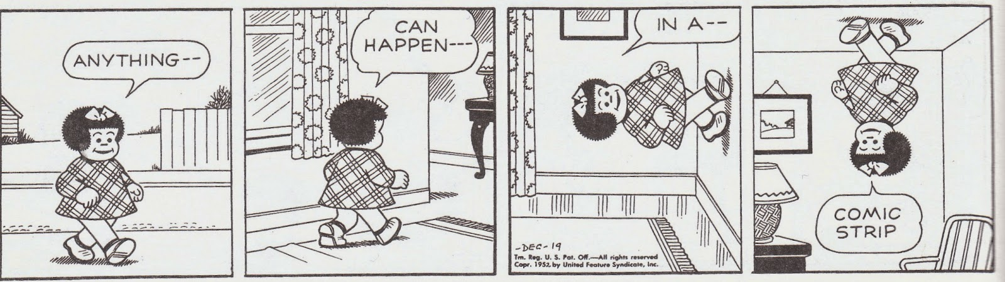
Summary
Starting with the familiar Peanuts comic strip characters in the form of video and print media, students explore comic strips as a form of communication of both fiction and nonfiction. In this lesson, each student creates an original comic strip to convey a mathematical concept to share with a younger student. The class then presents and shares the collection of comic strips as a math reference book to students in a lower grade.
Learning Objectives
Students will:
- Look at the evolution of comic strips using the familiar Peanuts comic strips and other comic strips
- Explore comic strips from the perspective of story (setting, character, plot)
- Evaluate comic strips by looking at words, pictures, and how they work together
- Create an original comic strip to convey mathematical information
- Share their comic strips with younger students as a reference tool
Teaching Approach
- Arts Integration
Teaching Methods
- Discussion
- Hands-On Learning
- Group or Individual
- Instruction Studio
Practice Assessment Type
- Performance Assessment
Please click here to view more about this lesson plan

Math and Arts Shapes and Patterns
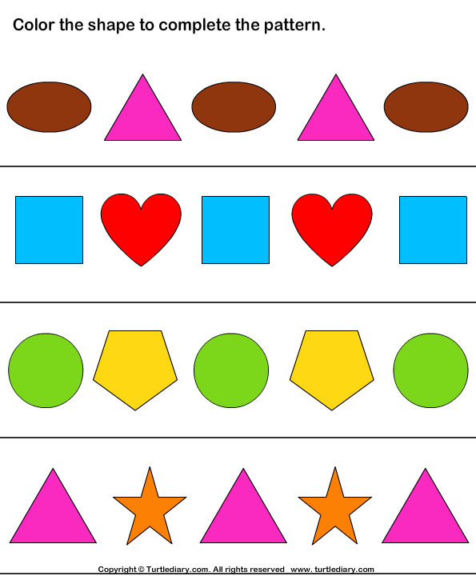

Lesson Summary
There are three options for this lesson, depending on class needs and time available:
- 1. Frame, Focus, and Reflection (view and discuss): students will watch a video about shapes in the real world, find shapes in the classroom, and identify shapes in art; students will draw “shape faces.”
- 2. Short hands-on activity: students will view a video about shapes and relative positions and explore right triangles.
- 3. Project (view and discuss): students will view a video about shapes and patterns and create a picture frame decorated with shape patterns.

Learning Activities
Frame, Focus, and Reflection
Introduce or review the names of 2-D shapes—square, circle, rectangle, triangle, and square. Talk about how these shapes are called “flat” shapes or “plane” shapes. It would be helpful to review this concept throughout the lesson and each day. Show Shape House and have students spot these shapes in the classroom. Show the PowerPoint Let’s Look at Art and have students identify shapes that they see in the paintings. Allow them to come up to the board and point out the shapes they see. Have students use the language “above, below, beside, in front of, behind, and next to” to describe the positions of these shapes. Pass out drawing paper and direct students to draw faces using shapes. Model on the board, using a large circle for the face with smaller circles for the eyes, nose, and mouth as students follow along. Then, draw a large triangle for a face and smaller triangles for the eyes, nose, and mouth as students follow along. Finally, challenge students to draw a face using large and small squares. Have students identify facial features using positional words. For example: “Your eyes are above your mouth.” “Your ears are beside your eyes.” “Your eyes are above your nose.”
Short Activity
Show Shapes All Around Me. Give each student a sheet of construction paper or lightweight colored computer paper, a right triangle template, and a crayon. Instruct students on how to hold down the template with one hand and trace around it with the other hand. It might be easier for them to do this working with a partner. After tracing, students will cut out the triangles with scissors. Have them look at the triangle shape and compare it to things in the classroom. Example: room corner, table tops, etc. Then, illustrate how to put two right triangles together makes a square. Give students time to experiment with combining their triangle with their neighbor’s triangle to make composite shapes.
Longer Project Show Peg + Cat: Triangle, Pentagon, Triangle, Square. Review the names of all shapes, review positional words, and lead a scavenger hunt in the classroom. Give students a bag of assorted shapes cut out of self-adhesive foam (should be cut in advance) and a tag board picture frame. Call out a shape and have students respond by holding up that shape (check to make sure). Then, have students stick that shape onto the frame. Call a second shape and so on, letting students create patterns from shapes until the frame is completely covered by shapes. Provide positional instructions to create a pattern (such as “Stick the square above the triangle”). Students will have a picture frame to take home. They could use it to frame the “shape faces” they drew the first day.
Formative Assessment What are the indicators of student progress toward or achievement of each learning target?
Math Assessment Problems
- Distinguished: Students can identify all shapes and use positional words to tell where the shape is located.
- Proficient: Students can identify all shapes and use positional words to tell where most shapes are located.
- Apprentice: Students can identify some shapes and use only a few positional words to identify location of shapes.
- Novice: Student cannot identify all shapes and does not use positional correctly.
Arts and Humanities
- Distinguished: Student created a clear pattern of geometric shapes. All pieces are securely adhered.
- Proficient: Student created a clear pattern of geometric shapes. Most pieces are securely adhered.
- Apprentice: Student created a pattern of geometric shapes with a few errors. Most pieces are securely adhered.
- Novice: Student did not create a pattern.
Program Review
Where does this fit in? How should you document it? This activity contributes to your school’s overall efforts in art programming in several areas, depending on whether you implement just the Frame, Focus, and Reflection portion or you implement the entire project. Curriculum and Instruction: Aligned and Rigorous Curriculum To what extent does the school ensure that the arts curriculum encompasses creating, performing, and responding and is fully aligned with the Kentucky Core Academic Standards? To what extent does the school ensure that the school’s curriculum provides opportunities for integration as natural cross-curricular connections are made between the arts and other content areas? To what extent does the school ensure that the arts curriculum includes the study of representative and exemplary works of dance, music, theater, and visual arts from a variety of artists, cultural traditions, and historical periods? Lesson Creators: Dianne Simpson, Lesa Gieringer, Amanda Varney, Melissa Roberts, and Judy Sizemore
For full access of lesson plan and more please click here

Math + Arts | Geometric Quilts

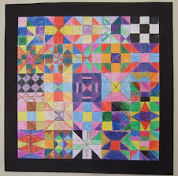
In this lesson, students will create a class quilt of nine patch paper quilt blocks using geometry. please click here for lesson plan.

More Examples
Quilting or weaving =Examples, Patterns, designs, shapes
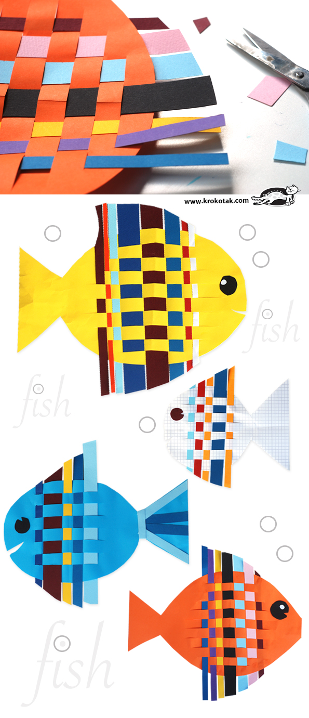

To make this fish and incorporate math to your own lessons please click here
I would diffuse the learning with and learning through incorporating the different types of cultures, geometry, and art. For example, each student will use a special type of quilting or weaving technique whether it be African, Mayan, or whatever they chose while learning math and creating their own masterpieces while learning history. For the kids that say they do not like math this is a great way to have them more absorbed in math

TESSELLATIONS
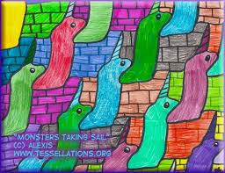
MATERIALS
- • Drawing paper, 9″ x 12″
- • Chipboard square, 3″ wide • Masking tape
- • Black marker
- • Crayons
DIRECTIONS
- 1. Start with a card stock square, at least 3″ wide. Label the four corners. Measure and mark the middle of each side of the square.
- 2. On the top right corner, draw and cut out a curve, leaving a little flat space that I call the “nose”.
- 3. The top curve piece is flopped and traced to make a symmetrical version below. Cut out the shape.
- 4. Both curved shapes are aligned and slide to the back of the square as shown. Tape in place. It is VERY important that the numbers read as shown as flopped and rotated shapes will not fit together when complete.
- 5. Cut one equilateral triangle from the bottom of the shape. It is slid to the top, aligned with the front of the fish and taped in place.
- 6. Place your fish on at least a 9″ x 12″ drawing paper, and trace. It’s best to make one row going across the paper first, and then add rows on top, always interlocking the shapes when tracing. Lastly, trace the lines in black marker and color with crayon. Artwork by M.C. Escher. Many more can be performed also view many more tessellations done by M.C. Escher

Theatre

Overview:
This lesson showcases teaching interpreting remainders through drama. This math lesson incorporates Drama to teach interpreting remainders in 4th-6th grade math. By acting out scenarios of real-life problems, students get the chance to emotionally and physically connecting to math that pencil and paper calculations just can’t provide. This math lesson focuses on cooperation and collaboration to solve a problem using the Actor’s Tools from which students can use critical thinking skills to master. It really hits Common Core objectives, 21st century learning skills and Arts Integration strategies all in one lesson.
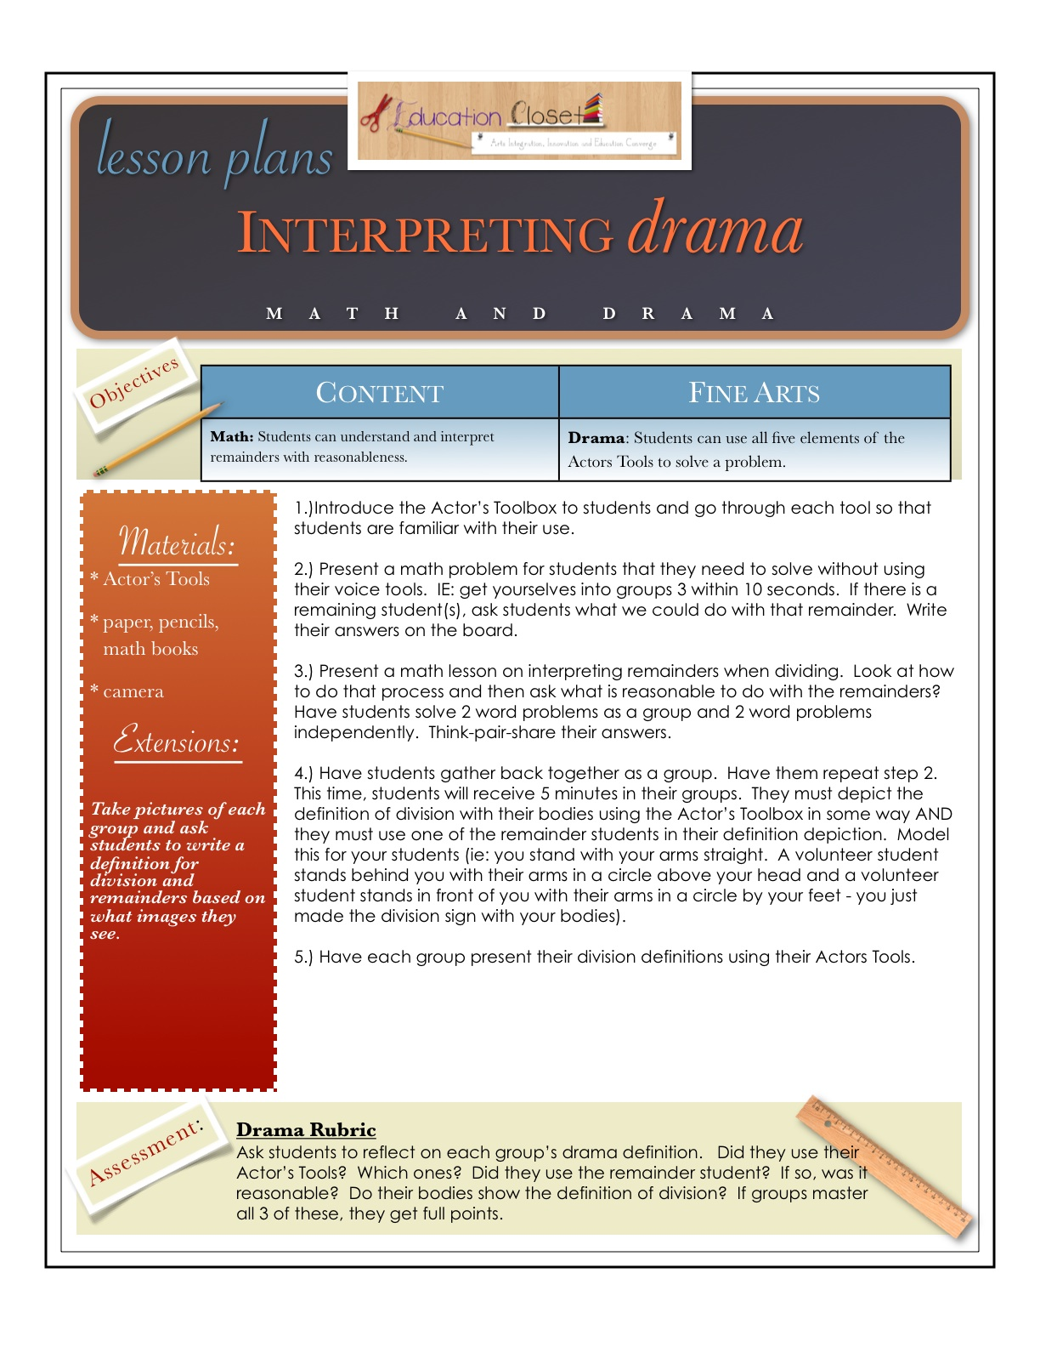
For more about math and drama please click here
Physical warm-up before a math a lesson
Must watch! Kids would have a blast.
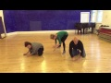Watch Video
Drama game for Kids. Honey and Feathers. Physical Warm up & Numbers
User: n/a - Added: 6/12/14

Physical Warm Up for 6-7 year olds. Simple stretches within a dramatic scenario. Great on its own or adaptable for any lesson. This one has a NUMERACY twist on it for the start of maths lessons.

Readers Theatre
America's got Math Talent Readers Theatre
Must watch video it is too cute!
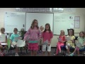Watch Video
America's Got Math Talent Reader's Theatre
User: n/a - Added: 9/10/13

Sending instructions to bake a cake at home, or watch a video on how one is made. After watching the video we can pretend we are baking one. I would provide the measuring cups and utensils. (Measuring)
Drama- Story Problems

Music
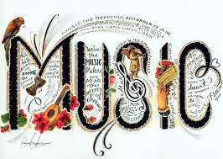

Math + Arts | Chinese Music & Dance:
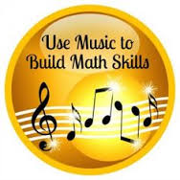
More or Less Students learn about Chinese culture and the concept of greater than and less than. After watching a student performance of a Chinese song and dance students are taught the difference between locomotor and non-locomotor motions. Students are asked to pay close attention to the number of musicians and dancers and apply the concepts of greater than and less than.
Lesson Summary
There are three options for this lesson, depending on class needs and time available.
- 1. Frame, Focus, and Reflection (view and discuss): teacher will show a video of a student percussion ensemble performing Chinese music and lead a discussion.
- 2. Short hands-on activity: activities related to greater than and less than
- 3. Project (view and discuss): integrating math, music, and dance
Learning Objectives
- Math I can write numerals up to 20.
- I can represent a number of objects with a written numeral.
- I can compare and record two digit numbers based on meanings of the tens and ones digits.
- I know what each symbol <, >, and = represents. I can use >, <, and = to record the results of comparisons.
Arts and Humanities
- I can begin to recognize that music and dance are performed in different cultures for different purposes
- I can begin to recognize the difference between locomotor and non-locomotor movement
- I can begin to play a steady beat;
- I can begin to copy locomotor and non-locomotor movements in a dance.
For full access to lesson plan please click here

Songs (Subtracting) (Adding)
Old McDonald (Subtracting)
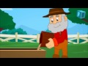Watch Video
Old MacDonald Had a Farm | Nursery Rhyme | Children Songs with Lyrics
User: n/a - Added: 10/5/13

If your happy and you know it clap your hands (Adding)

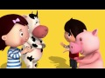Watch Video
If You're Happy And You Know It | Part 2 | Nursery Rhymes | by LittleBabyBum!
User: n/a - Added: 6/3/15

Head, Shoulders, Knees and Toes (Subtracting)

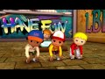Watch Video
Head Shoulders Knees and Toes | Nursery Rhymes | By LittleBabyBum!
User: n/a - Added: 8/17/13

Math Professional Organizations

National Council of Teachers of Mathematics
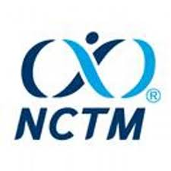

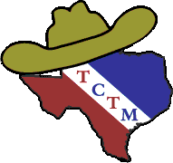Texas Council of Teachers of Mathematics

Click on link above to view website

Math Geeks Unite Professional Organizations for Math Teachers
Click on link above for more
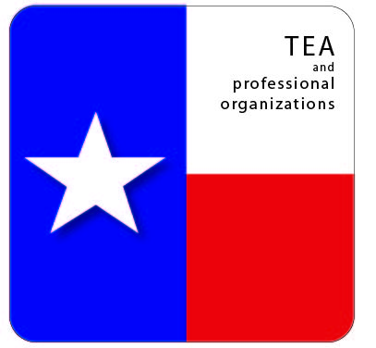

Math Periodicals

ASSOCIATIONS With PERIODICLES Please Click on links for more

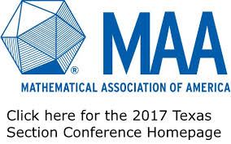
T-EB1 Mathematical Association of America: Texas Section. The
Texas section ofthe world’s largest organization for collegiate mathematics.
Contains membership information, employment opportunities, news, and descriptions of graduate mathematics programs throughout the state.

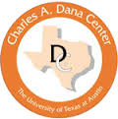
T-EB1a Texas Council of Teachers of Mathematics.
Professional organization for educators to study and increase their knowledge of effective teaching practices
in mathematics through their journal Texas Mathematics Teacher and an annual Conference for the
Advancement of Mathematics Teaching (CAMT).
Regional and local meetings and conferences of affiliated groups are highlighted through Lone Star News.
Membership required for access to journal and other member resources.

T-EB1b Texas Association of Supervisors of Mathematics.
Professional association for supervision, coordination and teaching of mathematics, especially
in K-12. Resources on the site include legislation updates for mathematics education related topics and presentations on the TEKS revisions.


T-EB1c Texas Mathematical Association of Two-Year Colleges.
Professional association for the teachers in the mathematics education experiences of students in two-year colleges.
Resources on the site include the TexMATYC Newsletter and a discussion board.

T-EB1d Association of Mathematics Teachers Educators.
Texas Section. Professional association promoting the improvement of mathematics teacher education in the state of Texas.

Math Book Lists
Bedtime Math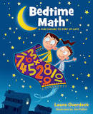By Laura Overdeck
This is a well-written, fun book for children that can help make them comfortable with numbers. It is well-known that increasing a child’s vocabulary is a major factor in a child’s success at school, but the value of basic number knowledge is less well-known. This book offers an entertaining way for children to see number relationships using common items and processes from their lives. It can help de-mystify math.
The Very Hungry Caterpillar 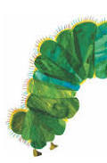 By Eric Carle
Although, this book is for younger children, we as future teachers need to consider the fact that not all of our students will have the opportunity to read a great book such as this one. Students may not have any books at home due to financial issues or whatever the problem may be.This book is great for the begging reader such as a child who does not have any books at home. This is not only just a good book for young children, but it is great for learning the days of the week, food(s), patterns, sequencing, ordinal numbers/order, and life cycles. There are also so many great crafts and activities that are inspired from this book.
Apple Fractions 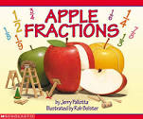 By Jerry Pallotta
Great book for introducing fractions this explains fractions so simply and entertainingly. The author gives you a concept, such as how to split an apple with three friends so everyone gets the same size piece, then gives a lesson about different kinds of apples - like Granny Smith or Cortland. The fraction pages are great because they explain things like denominators very simply without it feeling like a math lesson. The apple pages are great because they give the child a mental break from fraction concepts. This book helps children learn about fractions so the information sticks with them.
This is a great way to understand fractions in a fun and colorful format. Help children learn what they need to know to be a successful in life.
Math Fables 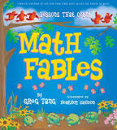 By Greg Tang Illustrator:Heather Cahoon
preschool-Grade 1--Complete with catchy titles such as "Trying Times," "Midnight Snack," and "Gone with the Wind," each brief fable told in rhyme ends with a moral. The author strives to help readers learn how to see a number as a combination of smaller groups of numbers in order to lay "the foundation for place value" and as a "first step to building strong computational skills." Computer-generated cartoons show youngsters that there are many different ways of putting numbers together.For example, in "Going Nuts," four squirrels frolic in autumn leaves until they realize they need provisions for winter. One begins to explore while three sit on a branch, frightened with worry. Next, "2 squirrels raced to gather nuts" while "the other 2… buried them in stashes underground." Finally, "all 4 slept very well that night,/no longer feeling scared./They learned it's wise to plan ahead/and always be prepared!" Cahoon keeps the different combinations together by enclosing them in ovals, visually emphasizing that although the groupings may look different, they still add up to four. Featuring words like "sultry," "wholeheartedly," and "procrastinate," the enriching vocabulary is an added bonus. A fine addition to math shelves.
--Marianne Saccardi, Norwalk Community College, CT Copyright © Reed Business Information, a division of Reed Elsevier Inc. All rights reserved.

For Lesson Plans Please Click here Math and Science Dr. Kathie Nunley's Layered Curriculum Web site for Teachers

Science

Quick Examples of Art

Visual Arts
Geology art project
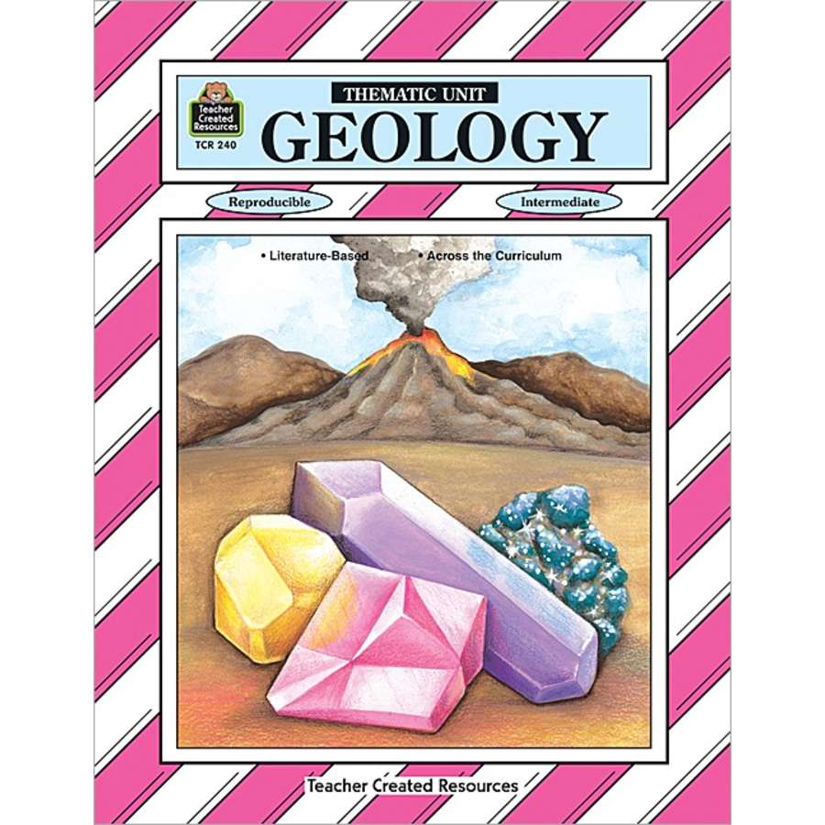

Download worksheets here
Title: Geology and Art
Work by: James Hutton
Grade: fourth Author: Maria Smith School: J. G.
Hening Elementary School
Topic: Geology is the study of the earth, artists can take note of the interesting patterns that make up the layering of the earth.
Integration: Science
Objectives: The student will create art that uses ideas and art forms from the past. The student will identify and use a variety of lines in a work of art.
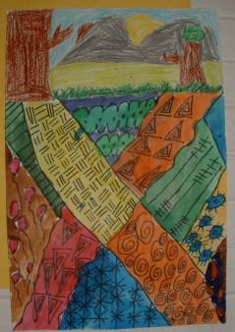

Too see more please click here

Solar System Art Project
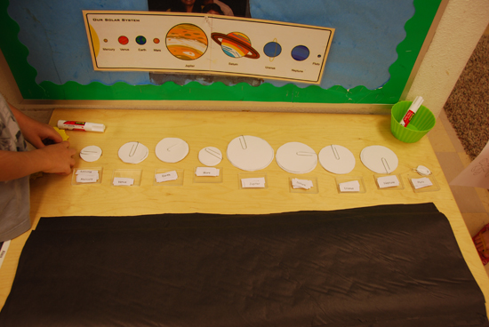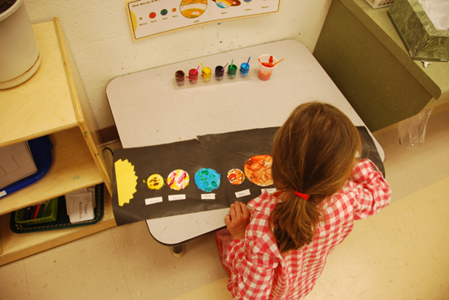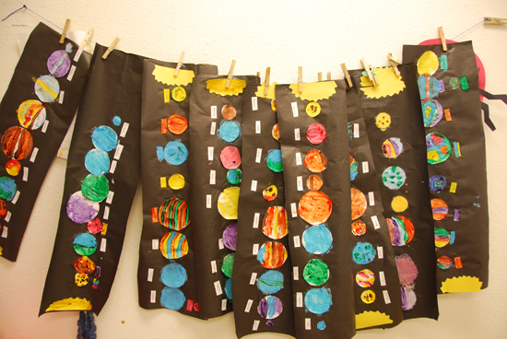
For more please click here

Earth Day
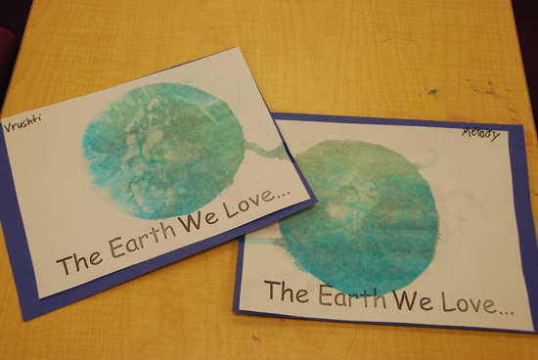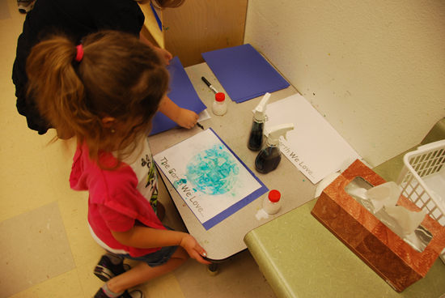
For more please click here

Draw and see and think
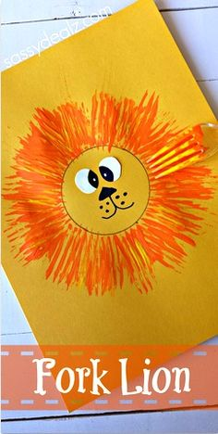 Encourage students to think about what they see, to see analogies between about what is observed and what brings to mind.

Theatre
Environmental debate
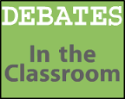
Debate in Activity section.pdf click link to view lesson plan and have students debate during the activity section.

Animal Features

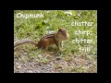Watch Video
✔ How To Spell Animal Sounds + Hear Noises They Make ~ Fun (full glossary)
User: n/a - Added: 3/17/13

Please click here for even more ideas

Project Wild

Sample Activity
This sample activity, "No Water Off a Duck's Back," exemplifies one of Project WILD's main goals: connecting people and wildlife. Simple and accessible, the activity helps students identify ways oil spills can adversely affect birds and describe possible negative consequences to wildlife, people, and the environment. Not only does the activity help students become aware of the wildlife we share our environment with, but it invites them to think about what we can do to protect them.
NoWaterOffaDucksBack.pdf
Click here for more
Point of View Props
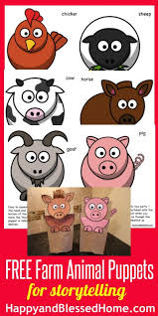

This lesson introduces students to six major livestock species, teaches that animals need air, space, food, water, and shelter to survive, and introduces students to the life cycle of a farm animal.
Please click here for full lesson plan

Music
The Science of Sound
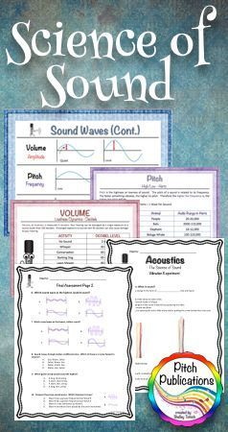
lesson plan is for grades 3-4 and integrates science with music. In this lesson, students learn about the qualities of sound through music and do science experiments based upon the sections of the orchestra.

For more please click here
The Rainforest Description
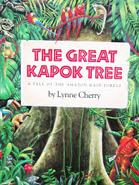
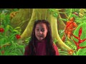Watch Video
The Great Kapok Tree by Lynne Cherry
User: n/a - Added: 1/16/16

Ecology-based teaching kit provides a unique look at a popular subject. Through Lynne Cherry's The Great Kapok Tree, children explore artists' perspectives on the rainforest by investigating their works. Lesson plans include language, science, music, and motor activities as well as extensive art enrichment. Based on the philosophy and approach of the Smithsonian's museum lab school.
Type Lesson Plan please click here for more
The Museum Connection:A Field Guide for Educators of Children 3 - 7 years
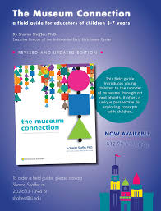
Smithsonian Early Enrichment Center
Must visit website

The Human body, Anatomy and Growth Music
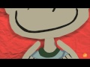Watch Video
Body Parts Song for Kids - This is ME! by ELF Learning - ELF Kids Videos
User: n/a - Added: 12/5/11

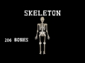Watch Video
The Human Body for Kids/Learn about the Human Body for Children/Skeleton
User: n/a - Added: 3/5/16

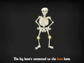Watch Video
The Skeleton Dance
User: n/a - Added: 9/7/09

Must watch videos my kids absolutely loved these.
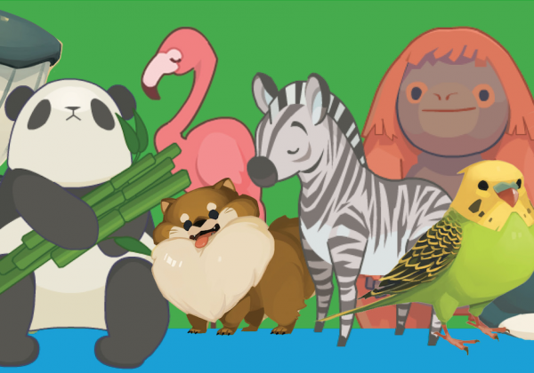For Science Game Center Please Click here

Science Periodicals
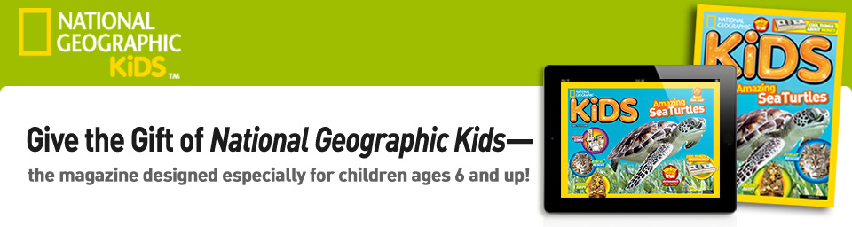

Click here to visit website

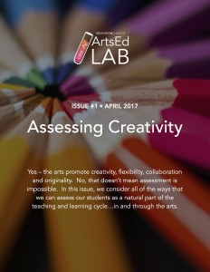

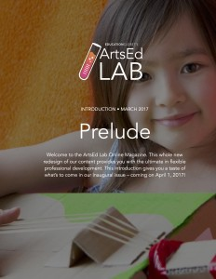

Please Click here to visit website

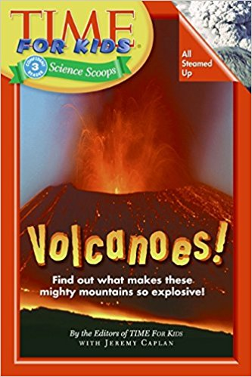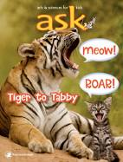
Click here for more

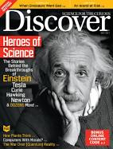

Science Professional Organizations

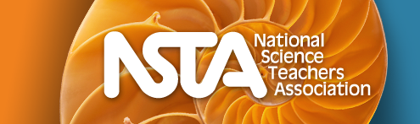
Please Click on Image above to be directed to the NSTA website.

Association for Science Teacher Education
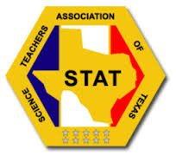

Please click on image above to view the STAT website

National Earth Science Teachers Association

STEM LESSONS & ACTIVITIES



Must visit website! Click On Image Above to Visit
Includes all core subjects. Intended for teachers, students, and parents.

Science Book Lists
by Lynne Cherry
This book did a wonderful job of showing how the animals of the rainforest depend on each other and the resources of the rainforest to live. I love how the book left you thinking about the man in the story and his decision not to cut down the tree. I used this in my classroom as a resource to show how/why the rainforest is endangered. The pictures in this book are great and really helped my students visualize what the rainforest looks like. I would recommend this book to any elementary classroom working on food chains, endanagered animals, or saving our environment.
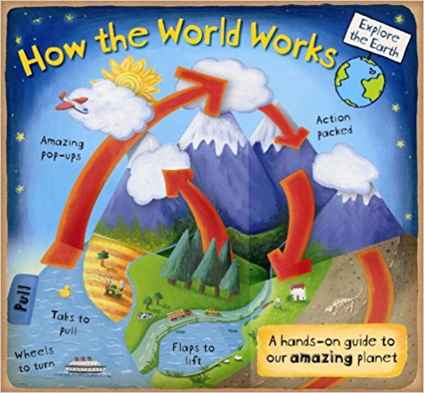by Christian Dorion (Author), Beverley Young (Illustrator)
Answering a multitude of questions about how our world works, this fun, engaging book introduces the earth’s important cycles and offers an exciting way to learn geography and science. Packed with illustrations and paper fold-outs, flaps, pops, and more to boost interactive learning, HOW THE WORLD WORKS encourages children to think about the impact of human actions on our environment, while engendering respect for the natural world and all its harmonies.

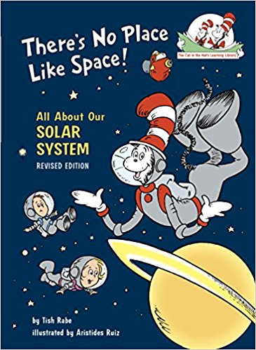by Tish Rabe (Author), Aristides Ruiz (Illustrator)
Kindergarten-Grade 3-Fans of Dr. Seuss's favorite feline will enjoy learning through rhymed couplets and cartoonlike illustrations similar to the originals. Each book combines basic facts with interesting trivia to introduce readers to topics that are sure to be of interest. From Bugs: "Here is a riddle/I learned from my mother./How's a skunk and a ladybug/like one another?/When danger is near,/it is easy to tell-/they suddenly give off/a terrible smell!" While the grammar is off, Seussian rhyme is rarely totally correct ("thunk"). In Space, readers learn, "On Venus the weather/is always the same-/hot, dry, and windy,/with no chance of rain." The familiar format and entertaining text are sure to appeal to beginning readers. Maura Bresnahan, Shawsheen School, Andover, MA Copyright 2000 Reed Business Information, Inc.

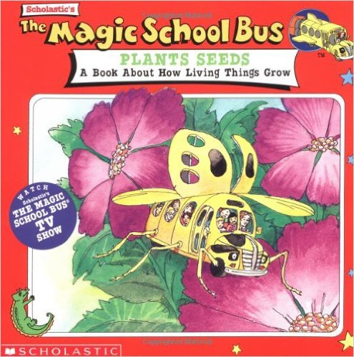by Joanna Cole (Author), Bruce Degen (Illustrator), John Speirs (Illustrator)
Ms. Frizzle's class is growing a beautiful garden. But, Phoebe's plot is empty. Her flowers are back at her old school! So, the class climbs aboard the Magic School Bus. And, of course, the kids don't only go back to Phoebe's school, but they go inside one of Phoebe's flowers! Follow the kids' adventure and learn how living things grow. From an episode of the animated TV series produced by Scholastic Productions, Inc. Based on The Magic School Bus books written by Joanna Cole and illustrated by Bruce Degen.

Social Studies

Social Studies Professional Organizations
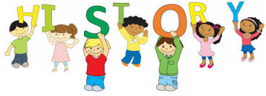
The Texas Council Of Social Studies

Texas State Historical Association

History Lesson Plans for Elementary

Martin Luther King Jr Lesson Plan for 5th grade

Quick Examples of Art

Visual Arts

Summary
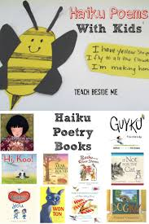
This lesson will introduce students to the Japanese poetic form haiku. Students will briefly examine the geography of Japan and Japanese culture through examples of Asian art and music. After learning about and listening to some examples of haiku, they will write their own haiku. Lastly, students will illustrate and "publish" their finished poems in the style of a Japanese scroll using rice paper, ink, and watercolor.
Learning Objectives
Students will:
- Count the number of syllables in each line of a haiku Listen to examples of haiku Describe the Japanese poetic form of haiku
- Write an original haiku Illustrate an original haiku
- Listen to Japanese music
- Discuss Asian art
- Discuss Japan's geographic features and location
Teaching Approach
- Arts Inclusion
Teaching Methods
- Modeling Demonstration
- Group or Individual Instruction
- Guided Practice
- Independent Practice
Assessment Type
Performance Assessment
An American Scene Painter
In what ways was artist Charles Burchfield inspired by nature?
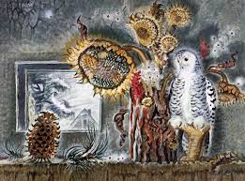
Summary
Students learn about American artist Charles Burchfield and his style of painting. Following Burchfield's example, students capture information and sketches in a personal journal, then use these ideas to create an original watercolor.
Learning Objectives
Students will:
- Become familiar with the artist Charles Burchfield.
- Record observations in a personal journal. .
- Create a watercolor painting based on the style of Charles Burchfield. .
Teaching Approach
Comprehensive Arts Education
Teaching Methods
- Discovery Learning
- Visual Instruction
- Studio Practice
- Independent Practice
Assessment Type
- Performance Assessment
Please click here for full lesson plan

Egyptian Symbols: What Story do they Tell?
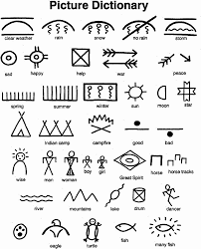
Grade Level: 3
Language Arts, Visual Arts, Social Studies, Ancient Art
Students will demonstrate understanding of the importance of symbols in Egyptian art by creating a symbolic stele using model magic to express personal ideas. The students will also write a description of their drawing in order to present a guide to their audience.
Please click here for full lesson plan

Music

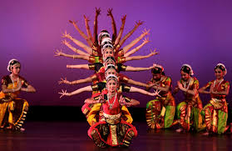
Summary:
Students will experience traditional Indian music and internalize it by moving to it. There will be an opportunity to listen to, play and dance to sitar music and ragas.
Suggested Grade Levels: 4-5, 6-8, 9-12
Country: India Region: Asia Culture
Group: Indian
Genre: Indian Classical
Instruments: Sitar
Language: Hindi Co-Curricular
Areas: Social Studies, Dance

For more please click here

Chinese New Year Music
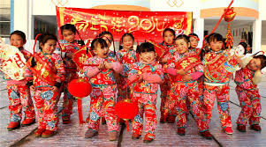

This highly engaging Social Studies lesson on Chinese New Year is integrated with elements of performing arts (drama). This lesson is appropriate for students in K-3, as it can be easily modified.
After a lesson on Chinese New Year, the learner will act out (role play) a 30 second scene from a traditional family visitation tradition using oranges, tangerines, and sweets.
Please click here for full lesson plan

Discover the History Behind "The Star-Spangled Banner"
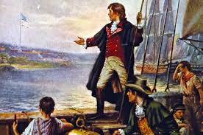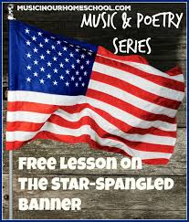
Students will learn about the history behind the writing of “The Star-Spangled Banner.” Students will develop an understanding of the significance of America’s national anthem through interactive online activities, writing blended poetry, and scripting a skit. Learning Objectives
Students will: Learn “The Star-Spangled Banner” Understand the history that influenced the song’s lyrics Learn about the individuals involved in writing “The Star-Spangled Banner” and the flag that inspired it Become familiar with the timeline of events leading up to the writing of “The Star-Spangled Banner” and with the related events since then
Teaching Approach
- Arts Inclusion
Teaching Methods
- Cooperative Learning
- Group or Individual
- Instruction Reflection
- Multimedia Instruction
- Brainstorming
Assessment Type
- Performance Assessment
Please click here for more

What Does This Song Really Say?
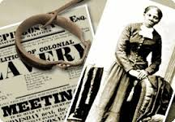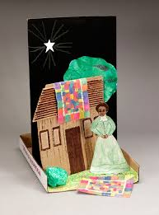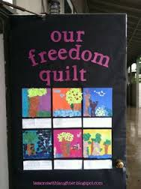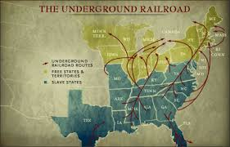

Summary
Students listen to, sing, and read the lyrics to various African American spirituals. They discuss the coded messages in the songs, and the purpose of these codes. Students then write original coded messages, and present their work in a performance format.
Learning Objectives
Students will
- Sing and/or listen to songs that are representative of spirituals sung by slaves Read lyrics of songs, and interpret the meaning of the lyrics, in terms of their cultural significance
- Write coded messages, and include interpretation Create an opportunity to share their coded messages through reading, drawing, a PowerPoint presentation, or another medium
Teaching Approach
- Arts Integration
Teaching Methods
- Cooperative Learning
- Discovery Learning
- Multimedia Instruction
- Problem-Solving
Assessment Type
- Performance Assessment
Please click here for full lesson plan

Theatre
Moral Dilemmas
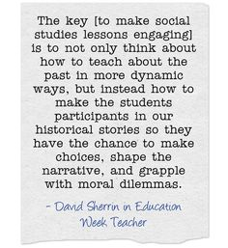

Portrait Conversations
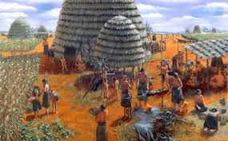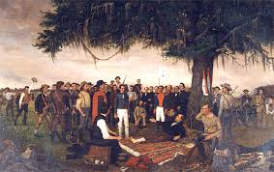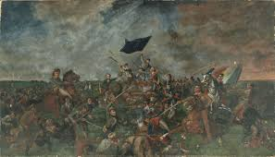
Biography Drama
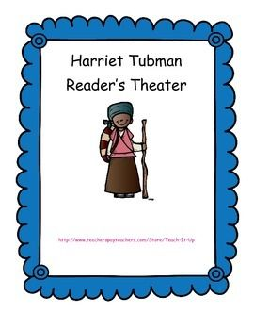

Costume Interpreters
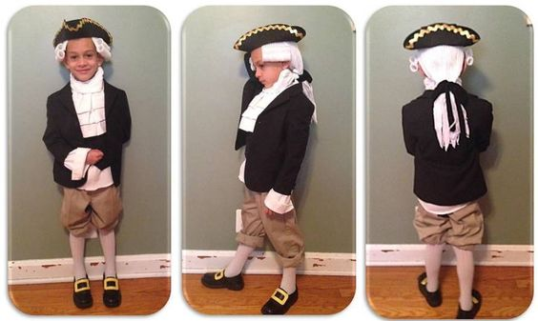
Planning a trip to the Petroleum Museum


Social Studies Periodicals
Social Studies Periodicals

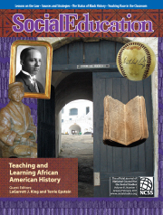

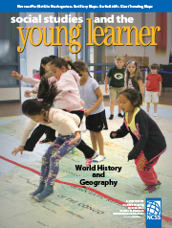

Social Studies Art Project
Recourses
https://www.slideshare.net/nwalkup/art-teks-for-quilting-wichita-falls-together
http://harringtonharmonies.com/2014/11/african-art-project-kids.html
Please click on link above to view African Art Project for Kids and More!
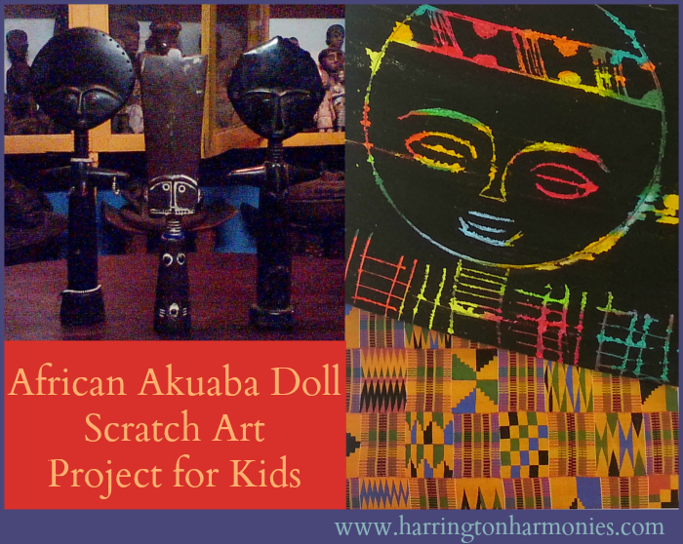
Social Studies Recourses
http://www.socialstudies.org/publications

https://tshaonline.org/education/teachers
https://www.scholastic.com/teachers/books/johnny-appleseed-by-reeve-lindbergh/

Social Studies Book Lists
Henry's Freedom Box by Ellen Levine, illustrated by Kadir Nelson
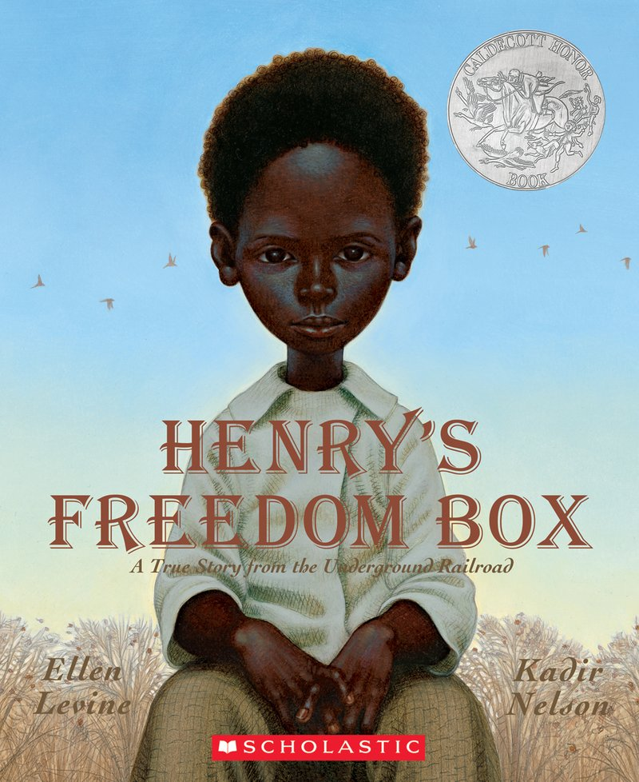
Grade 2–5—Inspired by an actual 1830s lithograph, this beautifully crafted picture book briefly relates the story of Henry "Box" Brown's daring escape from slavery. Torn from his mother as a child, and then forcibly separated from his wife and children as an adult, a heartsick and desperate Brown conspired with abolitionists and successfully traveled north to Philadelphia in a packing crate. His journey took just over one full day, during which he was often sideways or upside down in a wooden crate large enough to hold him, but small enough not to betray its contents. The story ends with a reimagining of the lithograph that inspired it, in which Henry Brown emerges from his unhappy confinement—in every sense of the word—and smiles upon his arrival in a comfortable Pennsylvania parlor. Particularly considering the broad scope of Levine's otherwise well-written story, some of the ancillary "facts" related in her text are unnecessarily dubious; reports vary, for instance, as to whether the man who sealed Henry into the crate was a doctor or a cobbler. And, while the text places Henry's arrival on March 30, other sources claim March 24 or 25. Nelson's illustrations, always powerful and nuanced, depict the evolution of a self-possessed child into a determined and fearless young man. While some of the specifics are unfortunately questionable, this book solidly conveys the generalities of Henry Brown's story.—Catherine Threadgill, Charleston County Public Library, SC Copyright © Reed Business Information, a division of Reed Elsevier Inc. All rights reserved.

The Princess and the Warrior a Tale of two Volcanoes by Duncan Tonatiuh
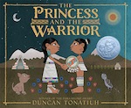
Bluebonnet award-winning Duncan Tonatiuh retells a famous historical traditional story. Princess Izta had many wealthy possessions but dismissed them all. When a simple warrior, Popoca, promised to be true to her and stay always by her side, Izta fell in love. The emperor Itza’s father promised Popoca if he could defeat their enemy Jaguar Claw, then Popoca and Izta could finally we since, the emperor condemned him. When Popoca was close to defeating Jaguar Claw, his enemy sent a messenger to Izta saying Popoca was dead. Izta drank a tea for her mourning and fell into a deep sleep and, upon his return, even Popoca could not wake her. As promised Popoca stayed by her side. He stayed by her side forever and untill this day he is still waiting. Two volcanoes were formed, Iztaccíhuatl, who continues to sleep, and Popocatépetl, an active volcano who still spits ash and smoke, trying to wake his love.
My Name Is Georgia By Jeanette Winter , illustrated by Jeanette Winter
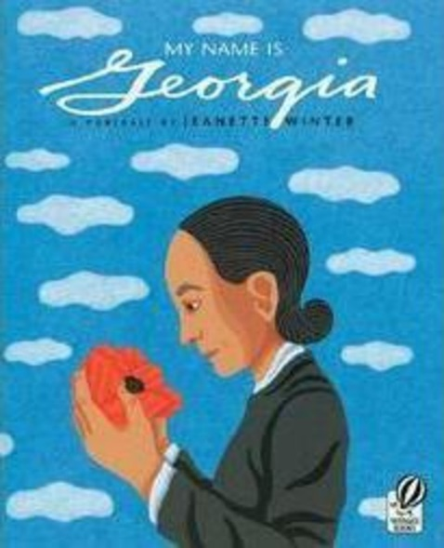
"When I was twelve years old, I knew what I wanted--to be an artist." So begins My Name Is Georgia, Jeanette Winter's lovely picture-book portrait of American artist Georgia O'Keeffe. It is a portrait of a strong-minded young girl who liked to play by herself, dress differently from her sisters, and let her black hair fly when others wore braids. And it is the portrait of an artist who lived to be 98 years old, letting the world see things as she saw them through her remarkable paintings. This small book--with sparse, carefully chosen prose--traces O'Keeffe's life through her schooling in Chicago and New York, and her first trek to Texas: "And I painted the sunset and the sky and the wonderful loneliness and emptiness of the place. I painted day and night." From there she experienced the "canyons of steel" of New York City, "where other artists lived," then it was off to the New Mexico desert. Winter does an exquisite job of reflecting an artist's creative life--how she wanted others to see flowers the way she saw them, how she painted them "BIG, so people would notice." The author's illustrations, perfect squares on white pages with the occasional cloud or bird drifting out of the lines, make this small, powerful tribute shine. (Ages 6 and older) --Karin Snelson --This text refers to an out of print or unavailable edition of this title.
Johnny Appleseed by Reeve Lindbergh Illustrated by Kathy Jakobson Hallquist
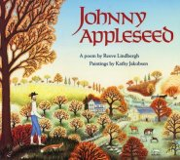
This homespun book provides the perfect vehicle for the story of the legendary Johnny Appleseed. Lindbergh's poetic narrative, related by an elderly woman to her grandchildren, tells the story of John Chapman's life and travels, including tidbits referring to his kindness and piety, his nonviolence and bravery, and his respect for all living things. Grandmother Hannah's tale, simply told, holds the power to mist readers' eyes. Finely crafted folk art illustrations, painted on canvas and overflowing with tiny details, complement quilt pattern borders on the facing pages of text. Small panels within these borders show vignettes of Chapman's life and legacy. The full-page illustrations embellish Hannah's story and provide a clear glimpse of life on the frontier during the early 1800s. The book includes a short introduction and a page of factual information at the end. A map on the endpapers shows the states through which Chapman travelled. Steven Kellogg's Johnny Appleseed (Morrow, 1988) is more of a compilation of lore about Chapman's bravery and great feats of strength, while Lindbergh's quiet tale emphasizes the man's true religious nature. It's a treasure. --Susan Scheps, Shaker Heights Public Library, OH Copyright 1990 Reed Business Information, Inc. --This text refers to an out of print or unavailable edition of this title.

