The Impact of Improving Technology ( Achieve 3000) Integration for Culturally Responsive teaching/intervention to student’s needs

Capstone Report
Andrea De La Cruz
ED 6383
Sul Ross University
Dr. Miller-Ray

Abstract

In this review, I have examined different articles, researched and analyzed the impact of utilizing Achieve 3000 in Core Content to incorporate technology to keep up with today's demand in tech-literate and the need to assist teachers in keeping up with the speed of new tech applications. The purpose of this research is to understand the impact of improving the use of Achieve 3000 integration in content areas such as Science and Social Studies for culturally responsive teaching and self-efficacy gains about reading intervention, all while merging the use of technology.

Table of Contents
Abstract………………………………………………………………………………………2
List of Figures……………………………………………………………………………......
List of Tables………………………………………………………………………………..10
Literature Review……………………………………………………………………………5
Research Question……………………………………………………………………………
Methodology………………………………………………………………………………….
Discussion……………………………………………………………………………………..
Conclusion……………………………………………………………………………………
Annotated Bibliography…………………………………………………………………….
Reference……………………………………………………………………………………..

Introduction

The purpose of technology in education is to build an educational foundation that an individual can continuously add onto throughout each progressive stage regarding digital literacy, instill social cues through digital interaction with peers, and develop 'one's opinions and views of the world. We can build an educational foundation while enhancing culturally responsive teaching and self-efficacy gains about reading intervention in core content areas such as Science and Social Studies in middle school.
Most businesses and jobs require computer literacy, and educators are expected to converge technology with core subjects. Technology skills are vital aspects educators are expected to teach, but we also want our students to be literate in Reading. The STAAR test is an evaluation every teacher in Texas is familiar with, and the STAAR test is difficult, even more so if a student is below their reading Lexile. I examined different articles, researched and analyzed the impact of utilizing Achieve 3000 in Core Content areas such as Science and Social Studies, resulting in an increased improvement rate.
In middle school, reading comprehension is essential to learn content. Unfortunately, our campus faces a challenge when it comes to students reading comprehension. One because it is difficult to teach reading comprehension skills, and two, teaching ELLs is even more challenging and three bridging the gap is an issue teachers face on a day to day basis. In this literature review, I have gathered valuable information to assist us in this matter, all while fusing technology as it has become the most crucial aspect in our daily lives.

Synthesis
Most businesses and jobs require computer literacy, and educators are expected to converge technology with core subjects. Technology skills are vital aspects educators are expected to teach, but we also want our students to be literate in Reading. The STAAR test is an evaluation every teacher in Texas is familiar with, and the STAAR test is difficult, even more so if a student is below their reading Lexile. I examined different articles, researched and analyzed the impact of utilizing Achieve 3000 in Core Content areas such as Science and Social Studies, resulting in an increased improvement rate. The objective of this study is to improve Reading on our campus. Research states that implementing Achieve 3000 in core contents improves testing scores. The goal of this investigation is to improve reading skills in 6th-8th grade students throughout the campus. In this review, I have examined different articles, researched and analyzed the impact of utilizing Achieve 3000 in Core Content areas, and combined technology to keep up with today's tech-literate demand.
In middle school, reading comprehension is essential to learn content. Unfortunately, our campus faces a challenge when it comes to students reading comprehension. One because it is difficult to teach reading comprehension skills, and two, teaching ELLs is even more challenging, and three bridging the gap is an issue teachers face on a day-to-day basis. In this literature review, I have gathered valuable information to assist us in this matter, all while fusing technology as it has become the most crucial aspect in our daily lives. According to (Ahmadi et al., 2013), research shows that reading comprehension is a complex process, and students usually have difficulties in constructing meaning from writing text (Grabe & Stoller, 2002). General study suggests that who starts to learn the English language is most likely to have serious difficulties in constructing meaning and understanding of the texts. This difficulty has been focused by investigators for a long time, and in recent years, they suggested that metacognitive reading strategy is an effective factor that fostering reading comprehension among readers (Salataki & Akyel, 2002). At our campus, we house the Newcomers Program, and my team and I teach ELLs and newcomers. We are aware that our students need to practice Reading to become literate. However, teachers are also expected to incorporate technology into their instruction.
(ISTE, 2008), states in using technology for instruction and learning, students gain more than just knowledge in core subject areas — they also acquire skills necessary to be productive and competitive in the workplace. (p. 4). In other words, a platform like Achieve 3000 application furnishes students' support not just in their knowledge of core academic areas but also in the skills necessary to be productive in higher education and the workplace, as mentioned in standards 6a and 6d. According to Rouse, "digital divide is a term that refers to the gap between demographics and regions that have access to modern information and communications technology, and those that don't or have restricted access. This technology can include the telephone, television, personal computers and the Internet." One of our goals as teachers is to help bridge the digital divide so that students can acquire the technological skills they will need to be successful as adults. While some students are considered digital inhabitants, having grown up immersed in technology, other students, for a variety of reasons, have not reached this level of technological skill. The digital divide is an issue we must overcome by having patience and giving students plenty of time to practice with the technology before assuming they are tech-savvy. The Achieve 3000 application is simple to use while enhancing tech skills. The ISTE suggests students must be prepared to thrive in a constantly evolving technological landscape. In other words, by incorporating Reading and writing or typing their learned knowledge in an enhanced software, students' are practicing tech skills.

Achieve3000 believes that the key to unlocking the potential of all learners is literacy. Teachers can facilitate students using Achieve 3000 to help with comprehension by reaching and teaching all learners at their individual reading levels and continually challenging them to achieve the next level of success. An English teacher at my campus has made literacy breakthroughs every day. According to Achieve 3000, students are doubling to tripling expected Lexile/reading gains with Achieve 3000's differentiated online instruction in a single year. The program personally tailors each lesson according to their unique level. Each lesson or article has a 5-Step Literacy Routine designed to improve fluency, vocabulary, reading comprehension and writing proficiency and build the literacy capacities students need to be college and career ready. ( Achieve 3000, 2016). Not only does the application accommodate students' needs, but the rigor gradually increases at their pace.
Research Question
What is the impact of improving the use of Achieve 3000 integration in content areas such as Science and Social Studies for culturally responsive teaching and self-efficacy gains about reading intervention?

Methodology
For my study, I used the Mixed Method Sequential Explanatory Design. In the first piece, I developed a questionnaire and distributed it to my peers. I then analyzed their response as shown in Table 1.1- 1.5.

For this research, I used primary data and secondary data collected from various scholarly articles. The quantitative data I analyzed did not provide enough information to grasp what I was looking for altogether. But I did, however, retrieve valuable information that supported my fellow teachers.

My search included a pre-survey, training, and a post-survey. I designed my first questionnaire to understand if teachers need assistance with technology integration, such as utilizing the Achieve 3000 application. After I explored the first survey, I mapped out a plan on how I will implement my training session. The session goes as followed:
- How to search for and assign articles/Collections
  - My Lessons
    - Collections: remove or add to auto-assign
    - Search under subject or search bar
      - Narrow by “factors into Lexile adjustment”
    - Assign to all classes
- Which articles count for Lexile adjustments
  - Technology Enhanced
  - 5-Step
  - Article + Activity
- Certain reports that will best help with implementation
  - Student Work
    - My Lessons
    - Activities
      - Limit the range and user if desired
  - Performance Reports
    - How are my students performing on reading skills?
      - Relevant to all
    - How are my students performing on activities?
      - Activities at 75% or higher
  - Lexile (with an external chart for Lexile to grade-level expectation)
- Classroom celebrations and accountability
- Sharing campus data
  - Overall trend: high quantity, low quality
    - On average, kids are doing more than one a week but scoring poorly.
    - No excuse for poor scores; the articles are literally on their level
  - Lexile growth despite less than ideal implementation
    - Attached
  - 73 students who have completed no activities
    - Not all MOA kids either
The Training is scheduled to take place on April 2, 2021.
The pre survey questions included multiple-choice and Likert scales. (Table 1.1-1.5) The final questionnaire was designed to collect their understanding of the Achieve 3000, check if they need additional support, and see if the information provided was beneficial.

Teachers were not selected as several decided to opt-out. Teachers who did choose to volunteer were the science teachers; in total, I had six participants. For this reason, more research must be conducted with more participants to get a better picture of this study.

The surveys were dispersed through email, and they had a week to respond to each survey; the response survey was 83% participation.
Pre- Survey Table 1.1-1.5
How often do you integrate technology into your curriculum?
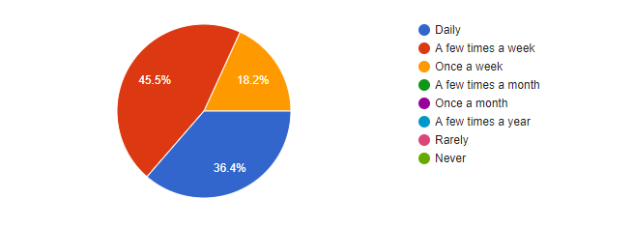
Table 1.1
How do you integrate technology into your curriculum?
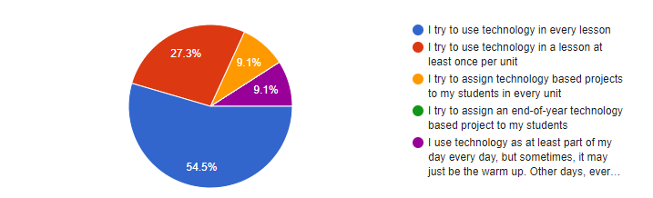
Table 1.2

How would you rank yourself as a technology user?
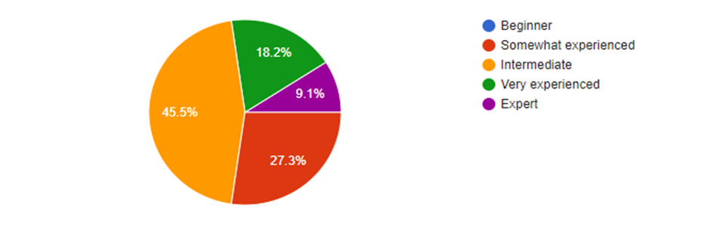
Table 1.3

What, if anything, is holding you back from using technology in your curriculum?
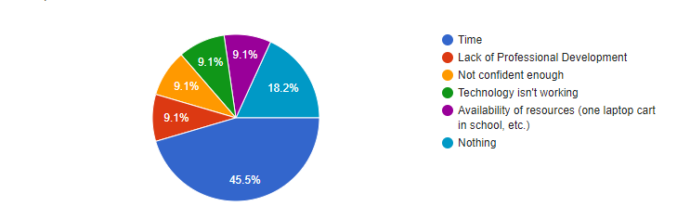
Table 1.4

Would an Educational Technology Professional Development program help your students and you engage in the learning process?
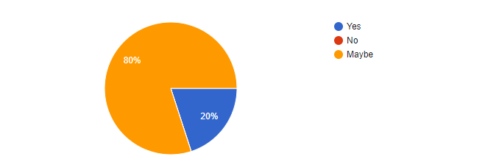
Table 1.5

Results/ Discussion
why do the results matter? The results indicate that
These devices are not going away anytime soon, and students will be expected to use them for the rest of their lives in their education and careers, as an educator it is essential to educate ourselves in the current tech trends to help our students. Teachers must continue training throughout their career as new trends and information emerge. Digital literacy is something educators must seek training in, as ideas move very quickly in the digital world. According to Halfpenny, “ ‘digital citizen’ is a person who develops the skills and knowledge to effectively use the internet and digital technologies; who uses digital technologies and the internet in appropriate and responsible ways in order to engage and participate in society and politics.” Teachers should consider facilitating students in becoming a successful digital citizen, and assist
Conclusion
Every day, students, educators, and children are surrounded by devices that are made to make life easier. These devices are what will execute a significant role in our 21st-century learners. It's easy to forget that these devices are also powerful tools of creation and learning.
Students are most likely no strangers to interacting with digital devices. However, they probably only use smartphones, tablets, or computers for playing games or watching videos. Bearing the digital divide in mind, teachers must promote digital literacy in their classroom while promoting Achieve 3000 by giving students time to use the application productively for learning. It is crucial to support digital literacy effectively for learning because, as mentioned by Meyers et al., digital literacies are required across the many places where we find digital tools and resources, including the changing landscape of how we access and use the information for personal and professional development. Informal learning opportunities are one key to bridging gaps between digital and non-digital media, old and new practices. We can incorporate old and new practice by utilizing both interchangeably. According to Danielson and Rodgers, the first step is getting students excited about Reading and demonstrating our own love of reading as teachers. We can't teach enthusiasm for Reading. Students must catch it from us. If we want to pass on this love of reading to our students, we must show students the impact that Reading has had on our own lives and encourage students to feel that power as well. (pg. 40). In other words, we can model this behavior, and students will inherit the love for reading. Something I have started in my classroom during advisory or intervention is allowing students to choose an article from Achieve 3000 to read something they enjoy. I have learned that students will acquire a love for Reading if they read something they enjoy. In conclusion, Reading and technology are necessary for one to succeed in academics and their future.

ANNOTATED BIBLIOGRAPHY

Allen-Brown, V & Nicholas, R. (N/A) Critical Theory and Educational Technology. University of Cincinnati.
The article possessed notions from many variables in our nation; from feminism to postmodernism. In addition, the material covered a broad view of many critics that one simply does not think of because we are so busy in the tech world. For example, I have not stopped to think about the little things that eventually add up. The article mentioned endless disadvantages or cons to technology such as Landow’s (1992) attraction to postmodern possibilities with computers is, in ecological terms, an appeal to using more of the Earth’s resources to produce computers and, at the same time, create more trash. It is bad enough that so few educational technologists ever look into the ways conventional educational technology philosophies, ideologies, and activities promote ecological degradation; but for educational technology critical theorists to omit to look at our own scholarship and the ways it offends ecology is, at best, ironic.I need to examine and learn more about how learners are suffering from technology when they are misused. The article states, “Many of the studies conclude that educational technology, instructional design, and computer use are focused on knowledge and learning that are too analytical, empirical, cognitive, decontextualized, and instrumental; this is to say that the technologies are not used as wisely as possible. A few authors (e.g., Nichols, 1993, 1994b) go so far as to say that learners suffer and technologists are morally suspect because educational technologies are misused.”
Daley, S. 31 Blockchain Companies Paving the way for the Future. (2019). Retrieved from https://builtin.com/blockchain/blockchain-companies-roundup on December 18, 2019.
Green, L.C. Bridging the Digital Divide in Our Schools – Achieving Technology Equity for All Students Retrieved from https://www.idra.org/resource-center/bridging-the-digital-divide-in-our-schools/ on November 26, 2019.
This article summarizes the most current data about the digital divide regarding poor students, minority, and limited-English-proficient (LEP). This article presents data in the U.S regarding access in school, in terms of hardware, software, and Internet access as well as issues in terms of how technology is used with these students. The article also states how teachers are prepared for technology integration. It closes with recommendations on how to decrease the divide based on a review of the literature and the author’s numerous years of experience in working with bilingual, English as a second language (ESL), and general program teachers on integrating technology into instruction in high poverty and high minority schools.
Halfpenny, S. (2015). Digital Society and the Information Age Retrieved from https://www.futurelearn.com/courses/digital-society/0/steps/23808 on November 25, 2019
Halfpenny explains how digital technologies have filled our everyday duties and interactions in the 21st century. They have transformed the way we learn, work and socialize. The dependence of utilizing technology in the modern world has driven too much attention to the consequences for society regarding how we engage and interact with each other and how we make use of these digital tools. She also exemplifies the importance of digital citizens.
Jarman, B. (2019) 2019 EdTech Trends You Should Be Excited About. Retrieved from https://elearningindustry.com/2019-edtech-trends-excited on December 17, 2019.
Jarman explains how educational technology has made tremendous strides over the years, and educators should expressly be encouraged for tech in 2019. He briefly covers smartboards, augmented reality, AR, adapting learning, and two new ed-tech applications that I have not heard of, such as Blockchain technology, and learning analytics. Blockchain technology is defined as a decentralized, distributed ledger that records the provenance of a digital asset. Learning analytics is described as an asset that allows teachers to follow the path that reveals how best their students learn. Teachers can then personalize a student’s learning based on that data.
Quin, P. (2019). Technology in Education 2019: 5 Trends to Watch. Education Technology. Retrieved from https://tophat.com/blog/technology-in-education-2019/ on November 25, 2019.
Quin eexplains the revelation of technology in his own words by referring to the analogy of a famous author ( Asimov) and his books that technology is taking over. While this may seem accurate when it comes to people who can't live without their phones, Parker provides the reader with five educational technologies that are sure to take over into the new year. He discusses AR or augmented reality, 5G that will replace 4G/LTE, Generation Z, and the importance of incorporating the use of technology for our future generation. Parker also warns the reader about the danger of ransomware and digital security.

Rouse, M. (n.d.). What is digital divide? — Definition from WhatIs.com. Retrieved from http://whatis.techtarget.com/definition/digital-divide on November 6, 2019.
In her article, Rouse provides the definition of digital divide. The digital divide is a term that indicates the pause between demographics and regions that have access to current information and communications technology, and those that don't or have restricted access. According to Rouse, technology can include the telephone, television, personal computers and the Internet.
Seong-Jae Min (2010) From the Digital Divide to the Democratic Divide: Internet Skills, Political Interest, and the Second-Level Digital Divide in Political Internet Use, Journal of Information Technology & Politics, 7:1, 22-35, DOI:10.1080/19331680903109402
After gathering and examining the efforts of Seong-Jae Min, his study endeavored to impersonate people's use of the Internet for politics. The research found that Internet use for politics is not equal depending on skills and motivational factors. Instead, what this study implies is that the mere availability of the new technology is not enough to encourage the meaningful use of technology for politics. Seong-Jae Min states, "the issue of the democratic divide warrants much attention. One solution to this problem is to build citizens' digital literacy or capacity. Along with universal access to the Internet, ongoing civic education on ICTs and their beneficial use are essential in the current information-based society. Implementing such a program will require the full cooperation and commitments of all parties involved—the civil society, government, and business."
Southern Regional Educational Board. (2019). Bandwidth. Retrieved from https://www.sreb.org/bandwidth on November 25, 2019.
According to the article Bandwidth, a possible solution for the Digital Divide is universal access to the Internet. Rendering to SREB, "access to affordable internet connectivity — or broadband — is a continuing struggle for K-12 schools and postsecondary education." While bandwidth increases, bandwidth-connected students increase too. Students are remarkably dependent upon their phone that the demand for evaluated emerging technology must satisfy educational standards. I need to learn more about emerging technology; I want to understand the method of pedagogical tools or emerging technology that may potentially enter my classroom before my students reach it to analyze it and see for myself if the emerging technology is or not educational.

References
Achieve 3000. (2016). Research to Practice.
https://www.achieve3000.com/media/resources/07_Research_to_Practice_2016_2oqQabu.pdf
Allen-Brown, V & Nicholas, R. (N/A) Critical Theory and Educational Technology. University of Cincinnati.
Daley, S. 31 Blockchain Companies Paving the way for the Future. (2019). Retrieved from https://builtin.com/blockchain/blockchain-companies-roundup on December 18, 2019.
Green, L.C. Bridging the Digital Divide in Our Schools – Achieving Technology Equity for All Students
Retrieved from https://www.idra.org/resource-center/bridging-the-digital-divide-in-our-schools/
on November 26, 2019.
Halfpenny, S. (2015). Digital Society and the Information Age Retrieved from https://www.futurelearn.com/courses/digital-society/0/steps/23808 on November 25, 2019
ISTE Policy Brief. (2008). Technology and student achievement – the indelible link. International Society for Technology in Education
Jarman, B. (2019) 2019 EdTech Trends You Should Be Excited About. Retrieved from https://elearningindustry.com/2019-edtech-trends-excited on December 17, 2019.
Quin, P. (2019). Technology in Education 2019: 5 Trends to Watch. Education Technology. Retrieved from https://tophat.com/blog/technology-in-education-2019/ on November 25, 2019.
Rouse, M. (n.d.). What is digital divide? — Definition from WhatIs.com. Retrieved from http://whatis.techtarget.com/definition/digital-divide on November 6, 2019.
Reza Ahmadi, M., Nizam Ismail, H., & Kamarul Kabilan Abdullah, M. (2013). The Importance
of Metacognitive Reading Strategy Awareness in Reading Comprehension. English Language Teaching, 6(10), 235. https://doi.org/10.5539/elt.v6n10p235
Seong-Jae Min (2010) From the Digital Divide to the Democratic Divide: Internet Skills, Political Interest, and the Second-Level Digital Divide in Political Internet Use, Journal of Information Technology & Politics, 7:1, 22-35, DOI:10.1080/19331680903109402
Southern Regional Educational Board. (2019). Bandwidth. Retrieved from https://www.sreb.org/bandwidth on November 25, 2019.

